Abstract
The digital divide in childhood education gets much worse when there are no artificial intelligence tools built specifically for regional languages like Assamese. Standard global AI models struggle these low-resource languages. They often give answers mix Assamese vocabulary with Hindi or English and provide complex answers that overwhelm young learners. To address this gap, we introduce “JONAKI”. Jonaki is a chatbot designed for Class 3 and 4 Environmental Science (EVS) students in Assamese medium-schools. This AI tutor is powered by Sarvam-30B. It is a language model trained to understand and generate Indian languages accurately. The system uses an architecture called Retrieval-Augmented Generation (RAG) to ensure that the answers are factually correct. It searches through versions of state curriculum textbooks, available as PDFs, by projecting the data (textbooks) onto complex vector planes, followed by a secondary verification sequence. By using a semantic routing mechanism, the chatbot then provides Assamese answers without using complicated scientific terms, and maintains an instructional yet approachable lexicon. A built-in system known as Reinforcement Learning Human Feedback captures user feedback to improve the teaching quality. The results show that Jonaki is highly accurate. It has a 95% accuracy rate in retrieving information from textbooks. All users accepted this chatbot. There was 0% language mixing rate. Jonaki provides an accurate digital tutor. Its design allows for expansion to other curriculum subjects. The chatbot help students to learn Environmental Science in Assamese. Jonaki is a tool for students, in Assamese-medium schools. It provides simple answers to their questions.

Chapter 1: Introduction

Section 1.1: Growth of AI Chatbots in Education

In this section, we have addressed how artificial intelligence is rapidly altering the way we live, work, and learn. AI is mostly chatbots and conversational agents, through which people interact with it frequently and in powerful ways. To put it simply, a chatbot is a computer program that mimics a human conversation via text or voice. Chatbots were initially meant for simple activities like customer service or answering customers’ frequently asked questions on the business website. They now have an extremely valuable role in education. In modern education, it can become a digital assistant or a 24/7 personal tutor. Students can ask their queries anytime during the day and get immediate personalised answers. When a human teacher is not possible, this helps students understand difficult topics outside of the physical classroom environment. The unceasing accessibility to online resources is an important advancement in education, making learning interactive, personalised, and accessible in ways that would previously have been impossible for most students [1] [33].

Section 1.2: The language barrier

This section discusses how the technological revolution has not benefited everyone equally [3]. Many powerful AI systems like ChatGPT or Google Gemini are highly optimised for the English language in decoding or coding. The global systems often face difficulty with regional Indian languages. The term “low-resource language” is used in the AI field to describe languages, including Assamese. Simply put, it means there isn’t enough high-quality digitised text available on the internet for global computer models to train on for flawless understanding and speaking of the language [3] [26]. Assamese is a rich language spoken by over 15 million inhabitants. Still, the AI gives convoluted responses, produces false facts, and mixes Assamese words with Hindi or Bengali words when young students try to use global AI tools to learn using Assamese. If even these models use correct Assamese vocabulary and provide simple answers, they will not be consistent enough for reliable use. At the primary school stage, when a learner is just beginning to learn basic science and grammar, this kind of cross-lingual mixing is not just unhelpful; it is highly confusing and counterproductive to learning.

Section 1.3: Challenges faced by Vernacular students

Young students in Assamese-medium schools face major real-world educational challenges, in addition to the language barrier. The main problem is the lack of direct access to adequate study materials at home. Many students from rural and developing areas do not have physical copies of specific textbooks recommended by their teachers. When they need to do homework, clear a doubt, or study for an upcoming exam, they may turn to the internet or existing global AI chatbots, or their parents may do so for them.
This poses a serious academic problem: general AI models provide very generalised answers. If a Class 3 student asks a standard AI a simple question on ‘trees’ or ‘the environment,' the AI will scan the vast knowledge it has from the internet and provide a highly advanced answer. It could tell you about complex biology, global warming, or cell structures in words that a high school or college student could understand. Most importantly, these answers often don’t match up at all with the local school curriculum. The teachers expect the young students to learn and write answers exactly from what is taught in their specific prescribed curriculum textbooks. This is not consistent with general AI, where students get information that is factually correct globally but academically wrong for their specific grade level and syllabus. These specific, overlapping challenges form the primary motivation behind this project.

Section 1.4: Research Gap and Motivation

It is important to note that the development of AI for regional languages is not a completely unexplored field. In recent years, several localised chatbots and NLP tools have been developed specifically for the Assamese language to help bridge the digital divide [7] [23] [29]. However, while these existing models successfully process the Assamese language, they are almost exclusively designed as general-purpose conversational agents, news summarizers, or translation tools.
A significant unaddressed gap exists in primary education. Existing Assamese chatbots lack a pedagogical approach. They do not adopt a child-friendly persona; their vocabulary is far too formal for an 8-to-10-year-old, and critically, they are not grounded in any specific academic syllabus. If a student asks them an educational question, they try to generate a generalised answer from the open internet. This causes the exact curriculum-alignment problems we mentioned earlier. We need a digital tool that solves the language barrier and the educational curriculum problem at the same time. This project introduces "Jonaki," a chatbot that teaches Assamese-medium students in Classes 3 and 4. We chose the name "Jonaki" because it translates to "firefly," symbolising a small but powerful guide for young learners navigating the digital world.
Jonaki is designed to be a helpful tool that can make learning easier and more fun for young students who speak Assamese. By using Jonaki, we hope to make a big difference in how kids learn and understand their language and curriculum. The idea is to create something that can be used by many people and that can help solve the problems of language and education that we are facing today. In Jonaki, we believe in making learning easier and more accessible. Our main goal is to help students get the right answers from their textbooks, rather than searching the whole internet. We do this by using the actual curriculum textbooks, like the SCERT Environmental Science book, to give students the information they need. This way, even if a student does not have their book at home, they can still get answers that match what their teacher is looking for and what's in their school curriculum. This helps students learn more effectively and ensures they're on the right track. By using the official textbooks, we can make sure that the answers we give are accurate and relevant to what students are learning in class. This approach also helps students develop good study habits and understand the material better, which is essential for their academic success.

Section 1.5: Synopsis of System Technologies of Jonaki

Developing Jonaki was a big project that needed several new AI technologies to work together, especially for young learners. To keep things simple, the system is based on a few key technological parts. At the centre of Jonaki is Sarvam-30B, a very powerful and advanced large language model with 30 billion parameters. What makes Sarvam-30B different from Western models is that it was trained from the start to understand and generate Indian languages correctly. Since it naturally understands the grammar and vocabulary of Assamese, it's the perfect "brain" for the chatbot, allowing it to communicate fluently. The project uses a special method to make sure Jonaki only gives answers based on what's in the school syllabus. This method is called Retrieval-Augmented Generation, or RAG for short. You can think of RAG like a super smart digital school librarian. Instead of using the AI's general knowledge, the project team scanned the SCERT EVS textbooks, broke them down into small paragraphs, and stored them in a special database called ChromaDB. When a student asks a question, this digital librarian quickly searches the database to find the right paragraph from the textbook that matches the question. It then gives this paragraph to the Sarvam-30B AI, which reads it and turns it into a friendly and conversational response in Assamese. This way, Jonaki's answers are always based on what's in the school books.

Section 1.6: Core Features and System Potential
The whole thing is put together in a way that's easy to use and looks great, thanks to something called Chainlit. This makes it simple for anyone to use, even if they're not super tech-savvy. The interface is clean and straightforward, so students can just jump in and start using it without getting confused. Jonaki is equipped with several standout features designed to guarantee safety, accuracy, and pedagogical value. First and foremost is its strict adherence to a child-friendly persona. The system is programmed with internal behavioural rules (guardrails) that force the AI to act like a caring school teacher. It is explicitly instructed to avoid heavy scientific jargon. For example, instead of using complex technical terms directly, it will explain concepts at the appropriate level, ensuring every student can easily grasp the knowledge. Furthermore, if a student asks a question outside the current topic, the system is smart enough to provide an answer while reminding the student of its primary subject focus (for the time being), maintaining its structured educational role.
One of the key features of Jonaki is its built-in feedback system. After each answer, students are given the option to provide feedback by clicking either the "Helpful" or "Not Helpful" button. This feedback is then logged into a database, which helps the developers identify areas where the AI is doing well and where it needs improvement. This process, known as Reinforcement Learning from Human Feedback, allows the chatbot to be constantly updated and refined over time. What's more, the system is designed to prevent language mixing, so students won't suddenly be switched to a different language, which can be confusing. The system also provides exact page numbers for each answer, so students can see exactly where the information is coming from. This transparency is really important, as it helps students understand the source of the information and builds trust in the system. By getting feedback from students and using it to improve the AI, Jonaki can provide a more effective and personalised learning experience.
Section 1.7: Real Impact and Influence
Jonaki is more than just a software project—it's a real solution to a big problem in education. For students in Assamese-medium schools, Jonaki is like a digital tutor that's always available and speaks their language. It lets them ask questions without feeling scared of what others might think and gives them the right information based on their curriculum. Basically, Jonaki puts a smart, interactive version of their textbook in their hands, making learning easier and more fun. This is especially important because it helps level the playing field for students who might not have had the same opportunities otherwise. By providing a personalised learning experience, Jonaki can really make a difference in the lives of these students. It's not just about accessing information but about feeling comfortable and confident in their own learning environment. With Jonaki, students can learn at their own pace, without the pressure of a traditional classroom setting. This can be really powerful in helping them reach their full potential. Overall, Jonaki has the potential to be a game-changer for students in Assamese-medium schools, and its impact could be felt far beyond the classroom.
While this project was initially prototyped using the Class 3 and 4 Environmental Science syllabus to prove its effectiveness, the underlying software architecture is highly modular and scalable. This means the system can easily be expanded in the near future. By simply uploading new digital textbooks into the vector database, Jonaki's knowledge base can be exponentially expanded to cover every subject across all grade levels in the state curriculum. Ultimately, Jonaki demonstrates how advanced artificial intelligence can be ethically and effectively localised. It proves that by focusing on regional languages and strict curriculum boundaries, we can democratize access to high-quality digital education and ensure that students in low-resource language environments are not left behind in the global AI revolution.

Chapter 2: Project Overview
A customised educational AI chatbot, Jonaki (or Firefly), can be a personal tutor for Class 3 and 4 students around the clock. EVS students in an Assamese-medium school. The project was initiated to bridge the digital divide for students with vernacular languages who face language barriers and a lack of curriculum-integrated digital tools. This is why it has been called online. In contrast to general-purpose AI models, Jonaki is closely regulated to official SCERT textbooks, guaranteeing that its answers are academically correct and appropriate for 8-to-10-year-olds.
2.1 Project Objectives:
The primary aim of the Jonaki project is to close the digital divide in early childhood education by providing students in Assamese-medium schools with a localized, curriculum-aligned AI tutor. The specific objectives are:
- Develop a Specialised Linguistic Framework: This framework should help the AI understand and use one language at a time, like Hindi or English, but not mix them. This mixing of languages is called "language mixing." We will use an Indic language processing model called Sarvam-30B to achieve this.
- Ensure Strict Curriculum Alignment: To do this, we will use a way of generating answers called Retrieval-Augmented Generation (RAG). The AI will only use information from textbooks like Class 3 and 4 EVS textbooks to ensure the answers are correct and easy to understand.
- Create a Pedagogically Sound Interface: To design a safe, child-friendly user experience featuring a "teacher-like" persona that avoids complex jargon and uses simple vocabulary suited for 8-to-10-year-old learners.
- Optimise System Performance and Efficiency: We will use a router that helps the AI understand what the user wants. If the user just wants to chat, the AI will respond quickly. If the user has a question about studies, the AI will answer.
- Establish a Continuous Improvement Loop: To integrate a Reinforcement Learning from Human Feedback (RLHF) mechanism that captures student feedback ("Helpful" or "Not Helpful") to refine the AI's teaching quality and accuracy over time.
- Democratize Access to Educational Resources: To provide a 24/7 digital assistant that assists students who may lack physical textbooks at home, thereby reducing educational inequalities between vernacular and English-medium students.
- Support National and Global Educational Goals: To align the project with the National Education Policy (NEP) 2020 (focusing on mother-tongue education) and the United Nations Sustainable Development Goals (SDG 4 and 10) for quality education and reduced inequality.

Chapter 3: Review of Literature
In modern education, the transformation of AI chatbots from simple customer service to pedagogical tools shows an intense shift [24] [33]. In today’s world, educational chatbots serve as 24/7 digital assistants that provide fast, personalised answers to students outside the traditional classroom. The development of Jonaki is situated at the intersection of conversational AI, regional linguistics, and educational technology. This review provides a comprehensive analysis of the foundational research, technological frameworks, and linguistic challenges that inform the project's architecture, specifically focusing on the transition from generalized AI to domain-specific pedagogical tools for low-resource languages. Caldarini et al. (2022) offer a broad survey of recent advances, detailing the shift of chatbots from customer service roles to 24/7 personal digital assistants capable of providing immediate, customized support. In the study of Kuhail et al. (2022), the interaction between students and educational chatbots has been portrayed as an emerging field that offers interactive and accessible learning experiences that were unavailable to most students earlier [1]. Dan et al. (2023) introduced EduChat, a large-scale language model specifically designed for intelligent education, reinforcing the necessity of specialized systems over general-purpose foundational models. In current Natural Language Processing, the uneven distribution of linguistic resources offers a critical challenge. Joshi et al. (2020) highlight the “state and fate” of linguistic diversity, stating that powerful AI technologies are highly optimised for English while regional languages suffer the most [3]. The research on Foundation Models for Low-Resource Language Education (2024) addresses the specific difficulties in deploying foundational models in underserved vernacular environments, where global tools often exhibit "vocabulary bleed" or unnatural syntax [26].
In the AI field, the Assamese language is considered a “low-resource language," which means that there is insufficient high-quality digitised text available to train global models perfectly. The Assamese language is treated inappropriately by global models, mandating considerably more tokens to manage single words than English. A study of Assamese WordNet by Sarma et al. (2014) and Phukan et al. (2021) explains the morphological variety and sophistication of the language, leading to "cross-lingual bleed" [5] [6]. A study into the IndicNLPSuite by Kakwani et al. (2020) shows building monolingual corpora and benchmarks for Indian languages; specialised educational datasets remain scarce [2].
To eliminate “hallucinations” in Large Language Models (LLMs), researchers have shifted to Retrieval Augmented Generation (RAG). Swacha (2025) surveyed the application of RAG chatbots specifically for education, validating Jonaki's choice to ground its logic in SCERT textbooks. Recent research (2025) comparing RAG and GraphRAG for page-level retrieval in math and educational textbooks demonstrates that retrieval-based methods are the superior choice for maintaining academic consistency [22] [28]. Lewis et al. (2021) have concluded that RAG is crucial for research-intensive NLP tasks where a model must extract a reply from a verified external base rather than purely depending on internal weights [10]. In our Jonaki system, the implementation of RAG includes multiple core units. From the study of Liu et al. (2023), we have obtained that LlamaIndex gives a robust framework for node processing and metadata preservation [19]. From the research of Malkov et al. (2020), it has been obtained that the Hierarchical Navigable Small World (HNSW) permits quick approximate nearest neighbour searches within high-dimensional vector databases like ChromaDB [20]. "Generative Pre-training for Low-Resource Question Answering" (2026) focuses on integrating morphological constraints in Assamese language modelling, which informs Jonaki's native linguistic approach via Sarvam-30B [27].
The modern multilingual embeddings, like the M3-Embedding framework by Chen et al. (2024), discuss the support for multifunctional and native regional script processing [17] [18]. To ascertain whether the journey of AI tutors is safe and effective for children, it requires continuous improvement through human feedback. Ouyang et al. (2022), through their study, introduced the strategy of training models to obey a specific set of instructions via Reinforcement Learning from Human Feedback (RLHF) [15]. In addition, the significance of “red teaming” and executing guardrails to minimise side effects was highlighted by Ganguli et al. (2022), ensuring that the model maintains a “teacher-like” image [14]. Regional productivity and research tools such as Aakhor AI (Borno Labs) focus on voice-typing and accessibility, while foundational efforts like Navdyut AI and AxomiyaBERTa (Nath et al., 2023) represent leaps in native text generation and phonologically aware transformer modelling. Earlier chatbot iterations like Shiksha Mitra (Sarma and Pathak, 2023) and subsequent research into Bi-LSTM and Attention-Based approaches (Sarma and Pathak, 2024) explored deep learning for Assamese religious and general texts, providing a technical precedent for regional conversational AI. Pathak et al. (2022) on AsPOS and Tamang and Bora (2024) on centralized dataset repositories highlight the ongoing efforts to build the high-quality digitized resources necessary for robust Assamese NLP.
The growth of localised AI tools is strongly endorsed by national and global frameworks. The National Education Policy (NEP) 2020 of India focuses on multilingualism and the power of language, promoting education in the mother tongue and the incorporation of AI in classrooms [21]. However, these initiatives sync with the United Nations Sustainable Development Goals, precisely SDG4 (quality education) and SDG10 (reduced inequalities), by making access to finely crafted digital resources for underserved vernacular communities. Finally, the development of localized AI directly contributes to the United Nations Sustainable Development Goals, precisely SDG 4 (Quality Education), SDG 9 (Innovation and Infrastructure), and SDG 10 (Reduced Inequalities), by democratizing access to high-quality digital education for underserved vernacular communities.

Chapter 4: System Requirements
4.1 Software Requirements:
The software stack is designed for native Indic language support and efficient Retrieval Augmented Generation (RAG). It includes:
- Core Large Language Model (LLM): The core LLM is Sarvam-30B, a 30-billion-parameter model that uses a Mixture-of-Experts (MoE) architecture that activates 2.4 billion parameters per query for efficiency.
- Embedding Transformer: It is BAAI/bge-m3, which supports Assamese natively, providing 1024-dimensional vector embeddings and a large 8,192-token context window.
- Reranking Model: It is BAAI/bge-reranker-v2-m3 (Cross-Encoder), which is used for high-precision secondary filtering of retrieved textbook passages.
- Optical Character Recognition (OCR): The OCR used is Sarvam-Vision, which is specifically engineered to extract complex Assamese scripts and conjunct characters (যুক্তাক্ষৰ) from scanned PDFs and images.
- Orchestration Framework: It is LlamaIndex, which is selected for its superior node parsing, hierarchical indexing, and native metadata preservation capabilities.
- User Interface Framework: It is Chainlit, which is an asynchronous Python framework that enables real-time token streaming and built-in RLHF (Reinforcement Learning from Human Feedback) tracking.
- Vector Database: It is ChromaDB, used to store high-dimensional embeddings and perform rapid HNSW (Hierarchical Navigable Small World) mathematical searches.
- Data Storage & Logging: It is SQLite (managed via SQLAlchemy) for persisting chat history and RLHF feedback in a local database named jonaki_history.db.
- Programming Language: We have used Python, utilising libraries such as LlamaIndex, Chainlit, and re (regular expressions) for the intent-based semantic router.
4.2 Hardware Requirements:
While initial development was possible on standard hardware, full-scale deployment of the heavy AI models requires GPU acceleration.
- Development Environment: Initial prototyping and lightweight processing (using MiniLM models) were conducted on standard local CPU developer hardware.
- Production/Deployment Environment: To handle the 568-million-parameter BAAI/bge-m3 model and Sarvam-30B API calls with sub-second latency, the system requires a cloud-based T4 GPU environment (specifically utilised via Google Colab).
- Memory Management: The system leverages Grouped Query Attention (GQA) within the Sarvam model to compress GPU memory load, allowing for the handling of large workloads and long context windows efficiently.
- Connectivity & Networking: Cloudflare Tunnels are required to securely bridge the local/cloud deployment to a web-accessible URL for user interaction.
- User Access Device: Since the interface is web-based (Chainlit), students require a device with a modern web browser and internet connectivity to interact with the tutor.
The selection of Sarvam-30B as the core large language model (LLM) for Jonaki was a strategic architectural decision based on its native support for Indic languages, computational efficiency, and economic sustainability. The following sections detail why it was chosen over global open weights and its larger counterpart, the Sarvam-105B model.
1. Advantage of Sarvam-30B over Global Open-Weights (Llama-3, Mistral, ChatGPT):
Global foundational models, while powerful, are predominantly trained on English datasets and present several hurdles for regional educational tools.
- Native Linguistic Processing: Global models often treat Assamese as a "low-resource language," resulting in high "token fertility rates" (requiring up to 10 tokens to process a single Assamese word). Sarvam-30B was trained from scratch on 16 trillion tokens with a focus on 22 Indian languages, allowing its custom tokenizer to process Assamese natively.
- Natural Syntax vs. Translation: Models like ChatGPT often generate Assamese by translating English logic, leading to unnatural syntax. Sarvam-30B provides far more natural and culturally accurate Assamese text.
- Eliminating Language Mixing: Global models frequently suffer from "cross-lingual bleed," where they mistakenly insert Hindi or Bengali vocabulary into Assamese responses. Sarvam-30B, specifically optimised for Indic languages, maintains a 0% language mixing rate in Jonaki.
2. Justification for Sizing: Sarvam-30B vs. Sarvam-105B
While a 105-billion parameter model offers extreme reasoning capabilities, the 30B variant was selected due to three primary engineering constraints:
- Latency and User Experience: Primary school students (ages 8-10) have limited attention spans. Sarvam-30B utilises a Mixture-of-Experts (MoE) architecture, activating only 2.4 billion parameters per query. This ensures sub-second latency and real-time text streaming, whereas a 105B model intrinsically has a slower Time-To-First-Token (TTFT).
- Task Complexity Delegation: In the Jonaki architecture, the heavy cognitive work of factual recall is handled by the Retrieval-Augmented Generation (RAG) pipeline via ChromaDB. The LLM’s role is strictly limited to linguistic formatting and summarising facts into child-friendly language—a task that the 30B model executes flawlessly without the massive computational overhead of a 105B model.
- API Economics and Scalability: Computational costs in cloud deployments scale with parameter size. To ensure Jonaki remains financially sustainable and scalable for hundreds of students in Assamese-medium schools, the 30B model was chosen to keep the operational "burn rate" of API credits low.

3. Technical Fit for RAG:
- Context Window: Sarvam-30B features a 32,000-token context window, which is perfectly sized for the RAG pipeline. This allows the system to process multiple textbook pages simultaneously without the model "forgetting" the student's original question.
- Memory Management: The model utilises Grouped Query Attention (GQA), which helps compress the GPU memory load required for handling large workloads and long context windows efficiently.
4.3 Framework Justification:
1. LlamaIndex vs. LangChain:
The development of Jonaki involved a strategic selection of orchestration and user interface frameworks to ensure the system is optimised for retrieval-augmented generation (RAG) and child-friendly interaction. While LangChain is a popular general-purpose orchestrator for autonomous agents, LlamaIndex was selected as the primary data framework for several technical reasons:
- Advanced Data Ingestion and Node Parsing: Assamese text is linguistically complex, particularly with conjunct consonants (যুক্তাক্ষৰ). LlamaIndex’s specialised node parsers ensure that paragraphs and sentences remain semantically intact during chunking, whereas standard splitters in other frameworks often break sentences mid-thought.
- Native Metadata Preservation: In an educational context, providing exact citations is mandatory. LlamaIndex natively binds metadata—such as book name, chapter, and page number—directly to the data nodes during ingestion. This allows Jonaki to accurately cite the specific textbook page for every answer.
- RAG-Centric Architecture: Unlike LangChain, which includes significant overhead for external tools like web searchers or calculators, LlamaIndex is purpose-built for connecting private data (like school textbooks) to LLMs. This provides a more streamlined and mathematically optimised pipeline for document indexing.

Feature / Capability | LangChain | LlamaIndex
Primary Design Focus | Autonomous Agents and Tool Chaining | Data Ingestion, Indexing, and RAG
Data Chunking Logic | Basic text splitters | Advanced semantic node parsers
Best Used For | Chatbots that need to browse the web or trigger APIs | Applications querying private PDFs, textbooks, or local databases
Architectural Overhead | Heavy (includes hundreds of unused tool integrations) | Streamlined and highly optimised for document retrieval
Selection Status | Rejected (Unnecessary overhead) | Selected (for robust Assamese data parsing)
Table 1: Comparison table between LangChain and LlamaIndex

2. Chainlit vs Streamlit:
For the frontend, Chainlit was chosen over the industry-standard Streamlit to provide a true conversational experience rather than a data dashboard:
- Asynchronous Token Streaming: To keep 8-to-10-year-old students engaged, the UI must provide immediate visual feedback. Chainlit’s asynchronous model allows for real-time, token-by-token streaming of the AI's response, creating a smooth typing effect. Streamlit’s synchronous "top-to-bottom" execution model is inefficient for this type of real-time interaction.
- Built-in RLHF Integration: A core feature of Jonaki is the Reinforcement Learning from Human Feedback (RLHF) loop. Chainlit provides native decorators and interactive "Thumbs Up/Down" buttons, making it easy to capture and log student feedback into the system's SQL database.
- Stateful Chat Management: Chainlit natively supports resuming past chat threads via a built-in sidebar and its SQLAlchemy data layer. This allows students to log in and pick up a previous Environmental Science lesson exactly where they left off, maintaining a unified conversational history.

Feature / Capability | Streamlit | Chainlit
Primary Design Focus | Data Science Dashboards & Analytics | Conversational AI & LLM Chatbots
Execution Model | Synchronous (Re-runs the entire script on interaction) | Asynchronous (event-driven session management)
Token Streaming | Bolted-on; can cause UI reloading issues | Native, fast, and seamlessly integrated
Human Feedback UI (RLHF) | Requires complex custom component workarounds | Built-in native decorators and UI buttons
Chat History Management | Difficult to maintain across browser refreshes | Native SQLite/Cloud integration with thread resuming
Selection Status | Rejected (Inefficient for stateful chat) | Selected (Perfect for real-time AI tutoring)
Table 2: Comparison table between Streamlit and Chainlit

Strategic Architectural Choice: UI-Level Memory
The project strategically implements conversational memory at the Chainlit UI layer rather than within the LlamaIndex engine. This ensures that when the Intent-Based Semantic Router directs a user toward "small talk," the conversation is still recorded. If memory were handled only within the RAG pipeline, the system would be "blind" to casual greetings, leading to a fractured and confusing user experience.

Chapter 5: System Architecture and Methodology
5.1 Data Support and Processing:
The effectiveness of Jonaki as a pedagogical tool relies on a robust data architecture that prioritises curriculum accuracy and native linguistic integrity. The system follows a sophisticated pipeline to transform raw educational materials into a structured, searchable knowledge base.
5.1.1. Data Support: Sources and Versatility
The primary dataset for Jonaki is derived from the official SCERT (State Council of Educational Research and Training) Assamese-medium textbooks.
- Initial Scope: The current prototype utilises Environmental Science (পৰিৱেশ) textbooks for Classes III and IV.
- Format Versatility: The system is designed to handle diverse input formats, including scanned physical PDFs, digital-native PDFs, raw images (PNG, JPG, and TIFF), and compressed ZIP archives containing multiple documents.
- Scalability: Due to its modular architecture, the data support can be scaled vertically to include higher-grade materials (higher secondary or undergraduate) or horizontally to cover different subjects and competitive examination materials.
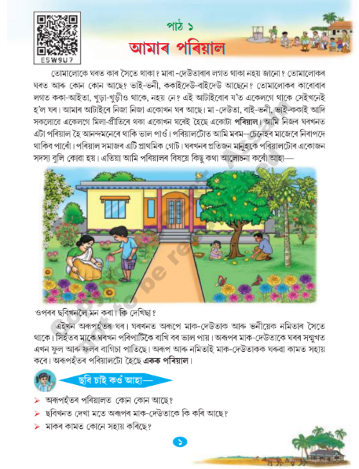  Figure 3: Screenshot taken from the original Class 3 EVS Textbook | 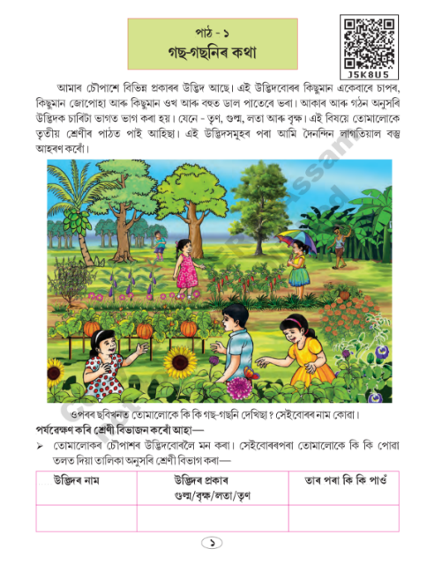  Figure 4: Screenshot taken from the original Class 4 EVS Textbook

5.1.2. Data Processing:
To convert visual textbook data into machine-readable text, Jonaki employs a high-precision extraction process:
- Sarvam-Vision OCR: All raw visual data is processed through the Sarvam-Vision model, an AI-powered Optical Character Recognition (OCR) tool specifically engineered for Indian regional languages.
- Script Normalisation: This model is capable of extracting complex Assamese scripts and intricate conjunct characters (যুক্তাক্ষৰ) from scanned pages with exceptional precision, converting them into a structured digital text corpus.
5.1.3. Data Processing Lifecycle:
Once the text is extracted, it undergoes a multi-stage lifecycle to ensure the AI can retrieve information accurately and instantly:
A. Heading-Aware Markdown Chunking: Unlike standard fixed-size splitters that might break a sentence mid-thought, Jonaki utilises a Heading-Aware Markdown Chunking strategy.
- Methodology: Processed text is converted into structured Markdown files. Using LlamaIndex node parsing, these files are divided hierarchically based on headers, sub-headers, and paragraphs.
- Pedagogical Benefit: This respects the original educational design of the textbook, ensuring that the AI receives complete, unbroken context for a specific lesson, which drastically reduces hallucinations.
B. Vectorisation (Mathematical Conversion): Each text chunk is converted into a high-dimensional mathematical array or "vector embedding" using the BAAI/bge-m3 model.
- High-Dimensional Accuracy: The model generates 1,024-dimensional vectors that capture the deep contextual meaning of Assamese sentences rather than just individual keywords.
- Context Window: By utilising the bge-m3 model, the system benefits from an 8,192-token context window, preventing data loss or truncation during the ingestion of text-dense pages.
C. Storage and Two-Stage Retrieval:
- Initial Broad Search (ChromaDB): Numerical embeddings are stored in a local ChromaDB vector database. When a student asks a question, the system uses the HNSW (Hierarchical Navigable Small World) algorithm and Cosine Similarity to rapidly retrieve the top-10 most relevant chunks.
- Precision Reranking: To ensure absolute accuracy, these 10 chunks are passed through the BAAI/bge-reranker-v2-m3 cross-encoder. This secondary filter deeply analyses the logical relationship between the question and the retrieved text, isolating the absolute top-3 most accurate passages for the AI to use.
D. Metadata Tagging and Citation Alignment:
Every data chunk is permanently tagged with metadata, including the source book, chapter name, and exact page number. This metadata remains bound to the text throughout the retrieval and reranking phases, allowing Jonaki to provide exact citations in its final response, thereby guaranteeing academic integrity and preventing the generation of fake sources
  - . Core algorithms used in Jonaki:
  - HNSW (Hierarchical Navigable Small World) Algorithm: it is used inside ChromaDB. When the user asks a question, Jonaki does not read the entire EVS textbook from start to finish—that would take too long. Instead, ChromaDB uses the HNSW algorithm to perform Approximate Nearest Neighbour (ANN) search. It builds a multi-layered graph of all our textbook chunks and mathematically navigates through them to rapidly fetch the top-10 nearest neighbours, serving as the high-speed first stage of our retrieval pipeline.

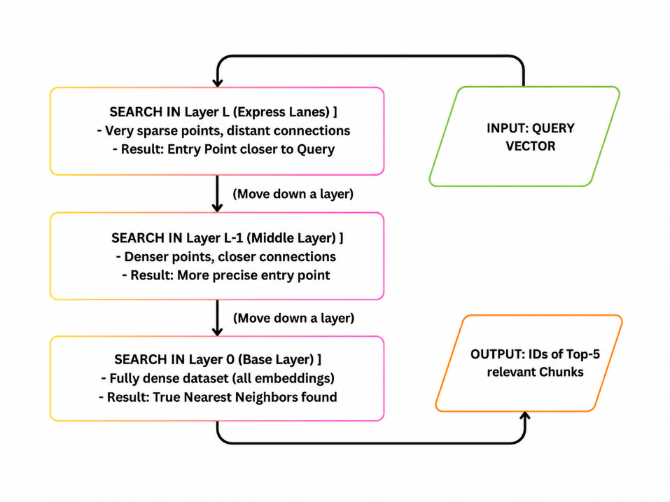
Figure 3: Flowchart for the HNSW (Hierarchical Navigable Small World) algorithm

  - Cosine similarity matrix: it is used between the 1024-dimensional BAAI/bge-m3 embeddings and the initial ChromaDB vector search. How does the computer know a paragraph about "Trees" is related to a question about "Oxygen"? It converts both the user's Assamese query and the textbook text into high-dimensional numerical vectors. This project specifically uses the Cosine Similarity mathematical formula to measure the angle between the user's question vector and the textbook chunk vectors. The smaller the angle, the higher the semantic relevance. This metric power the first stage of our retrieval pipeline, rapidly filtering the entire textbook database down to the top-10 most relevant chunks before they are sent to the cross-encoder for final precision reranking.

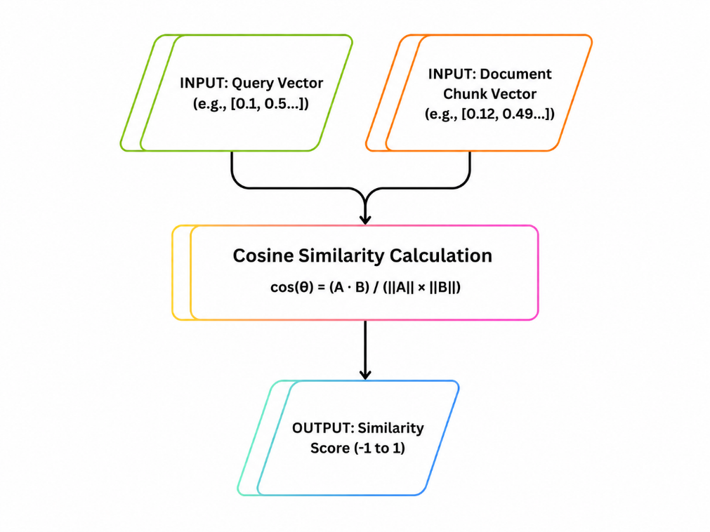
Figure 4: Flowchart for Cosine Similarity algorithim

  - Rule-Based Semantic Routing (Intent Classification): it is used Inside the main Chainlit’s script. It is a Deterministic Rule-Based Router. It uses exact keyword heuristics to calculate the user's intent in O(N) time complexity before the vector database is even touched. It mathematically guarantees that small talk bypasses the heavy RAG pipeline.
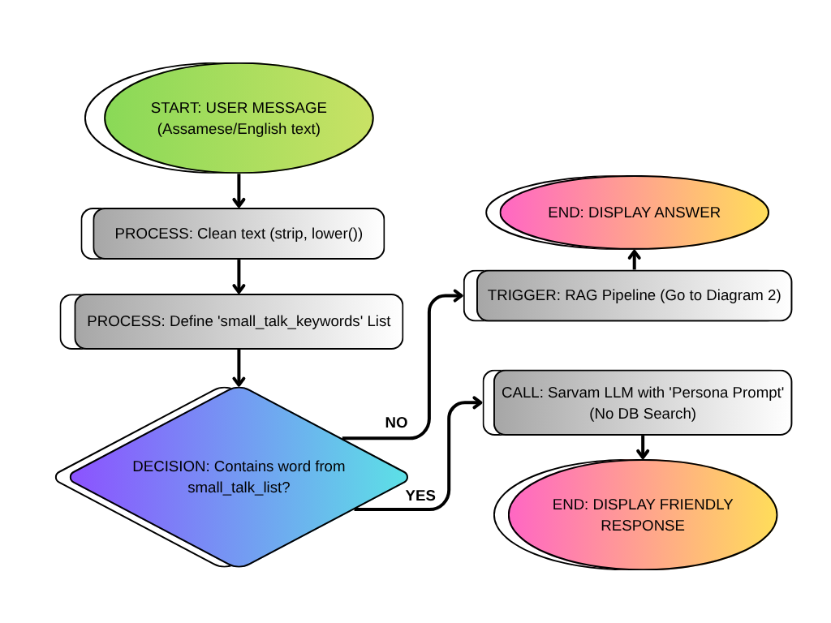
Figure 5: Flowchart for Rule-Based Semantic Routing algorithm

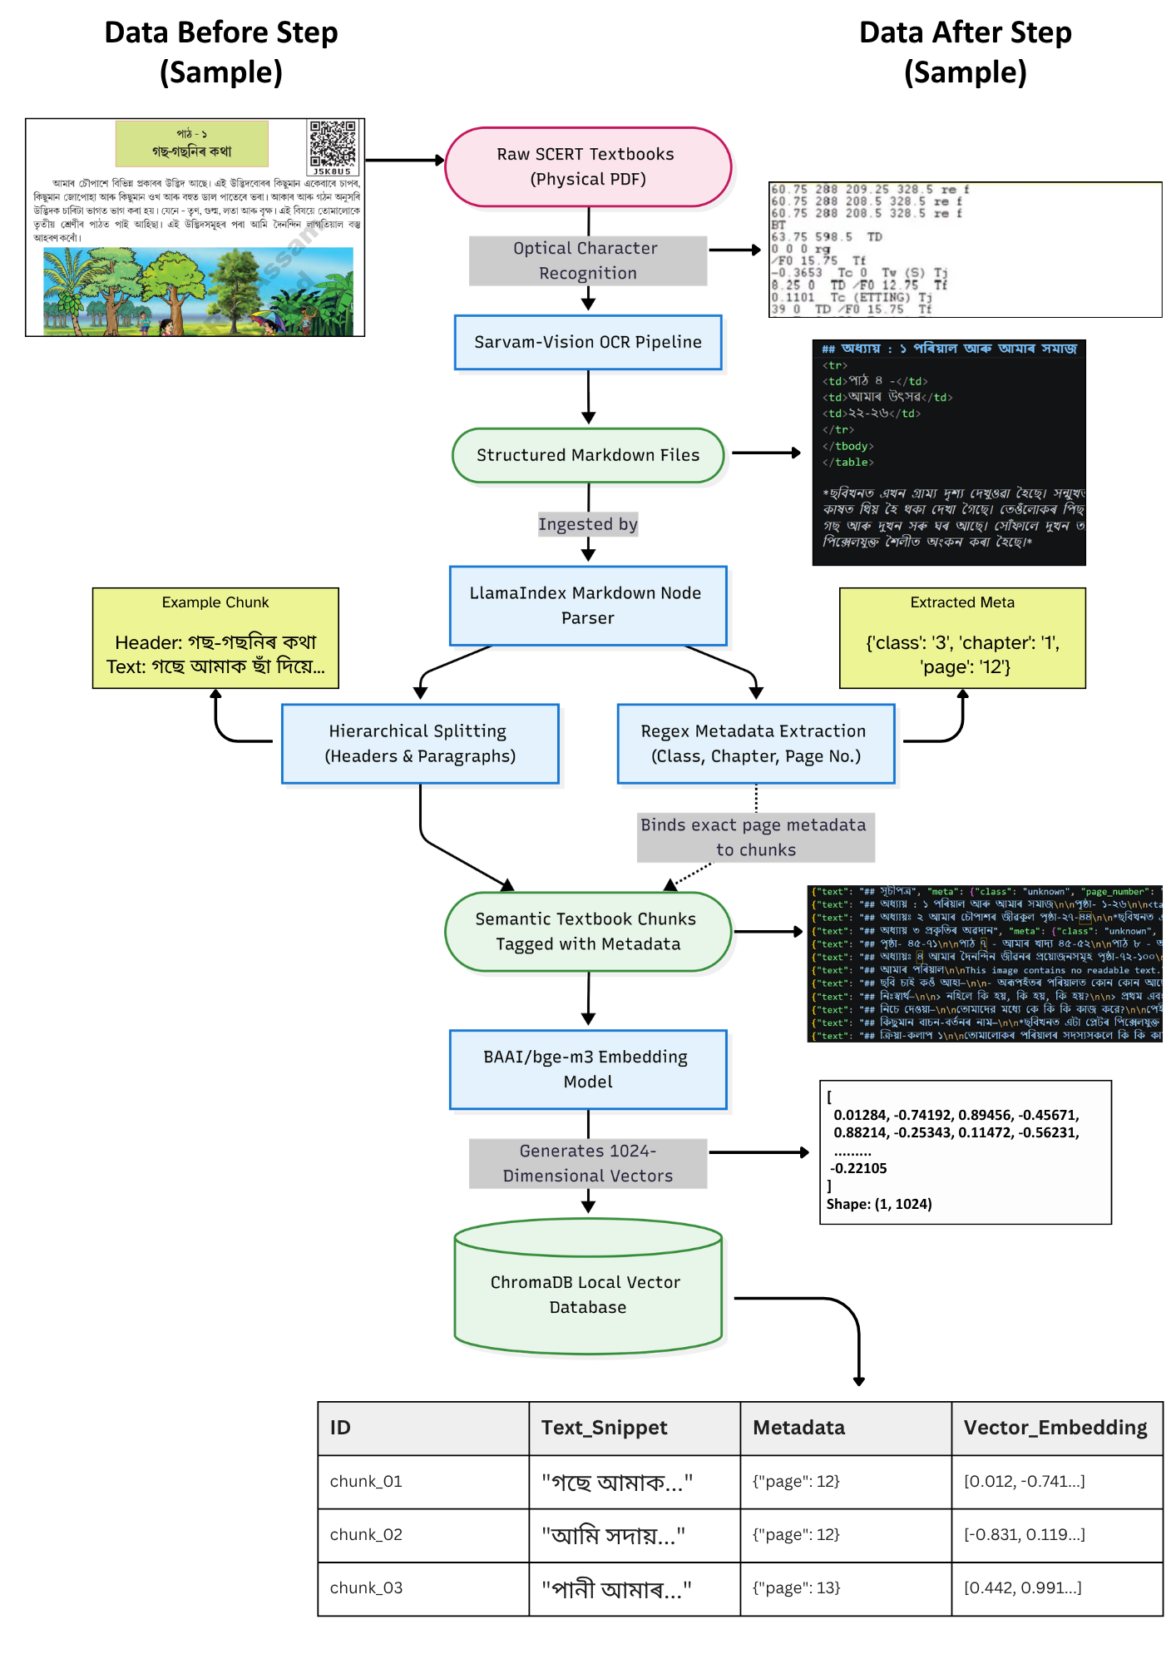Figure 5: The Data Ingestion and Chunking Pipeline. This flowchart illustrates the transformation of raw EVS textbook PDFs into mathematically embedded vector chunks, highlighting the LlamaIndex node parsing and metadata binding processes.

5.2. Retrieval-Augmented Generation (RAG) Pipeline:
The Retrieval-Augmented Generation (RAG) pipeline is the core architectural framework that ensures Jonaki remains a factually accurate, curriculum-aligned tutor for young vernacular learners. Instead of relying on an AI's general knowledge, which often leads to "hallucinations," the RAG pipeline forces the system to act like a digital school librarian, drawing answers exclusively from verified SCERT textbooks.
The pipeline functions through two main phases: Data Ingestion and Live Execution.
Phase 1: Data Ingestion (Preparation)
Before the system can answer questions, the physical textbooks must be converted into a searchable mathematical format:
- Extraction via Sarvam-Vision OCR: Scanned physical textbooks or PDF images are processed through the Sarvam-Vision OCR model. This specialised tool is engineered to extract complex Assamese scripts and conjunct characters (যুক্তাক্ষৰ) with high precision.
- Heading-Aware Markdown Chunking: Instead of splitting text at arbitrary word counts, Jonaki uses a Heading-Aware Markdown strategy. Text is converted to Markdown and divided into logical "nodes" based on natural headers, sub-headers, and paragraphs. This ensures that educational concepts remain unbroken and semantically intact.
- Vectorisation: Each text chunk is processed through the BAAI/bge-m3 embedding model, which converts the Assamese text into 1,024-dimensional vector embeddings. These mathematical arrays capture the concept of the paragraph rather than just keywords.
- Metadata Tagging: Every chunk is permanently tagged with "metadata," including the Source Book, Chapter Name, and Exact Page Number, to ensure every answer can be cited back to the physical book.
- Storage: These embeddings are stored in a local vector database called ChromaDB.
Phase 2: Live Execution (Retrieval and Generation)
When a student asks an academic question (e.g., "Why are trees important?"), The system triggers the following "EVS Textbook" execution flow:
- Broad Search (ChromaDB): The user's query is vectorised, and ChromaDB uses the HNSW (Hierarchical Navigable Small World) algorithm and Cosine Similarity to rapidly retrieve the top 10 most relevant textbook chunks.
- Two-Stage Precision Reranking: To guarantee accuracy, these top-10 chunks are passed through a secondary filter: the BAAI/bge-reranker-v2-m3 cross-encoder. This model deeply analyses the logical relationship between the query and the text, isolating only the top-3 absolute best passages.
- Prompt Injection and Guardrails: These top-3 passages are injected into a strict "Pedagogical Guardrail" system prompt. This instruction forces the Sarvam-30B Large Language Model to ground its answer only in the provided context and to use a simple, child-friendly "teacher" persona.
- Generation and Citation: The Sarvam-30B model generates the final answer in native Assamese. The system then dynamically appends the exact page numbers (extracted from the metadata) to the message so students can verify the information in their own books.
This end-to-end pipeline results in a 95% textbook retrieval accuracy and a 0% cross-lingual interference rate, ensuring a safe and reliable learning environment for Assamese-medium students.
5.3. Intent-Based Semantic Router:
The Intent-Based Semantic Router is a critical component of the Jonaki architecture designed to manage different types of user queries by directing them to the most efficient processing pipeline. It acts as a deterministic filter that calculates a user's intent in O(N) time complexity before the system even touches the heavy vector database.
The router primarily distinguishes between two distinct execution paths:
1. The "Small Talk" Execution Flow:
This route is designed for non-academic interactions, such as greetings or casual conversation, and is optimised for speed.
- Classification: The router scans the user's input against a predefined Boolean array of Assamese and English greeting heuristics (e.g., "নমস্কাৰ" or "hello").
- O (1) Bypass: If a match is found, the system completely bypasses the ChromaDB vector search, which saves approximately 400–800 milliseconds of retrieval latency.
- Pedagogical Redirection: After responding with a friendly persona prompt, the system actively steers the student back to their studies with a closing question like, "What topic from the EVS book should we discuss today?"
2. The "EVS Textbook" Execution Flow
If the router determines the query is academic, it triggers the full Retrieval-Augmented Generation (RAG) pipeline.
- Two-Stage Retrieval: The query is vectorised and sent to ChromaDB for an initial search of 10 chunks, which are then refined by a cross-encoder to isolate the top 3 most accurate passages.
- Grounded Generation: The Sarvam-30B model generates an answer strictly based on these retrieved textbook passages, ensuring the response is factually accurate and curriculum-aligned.

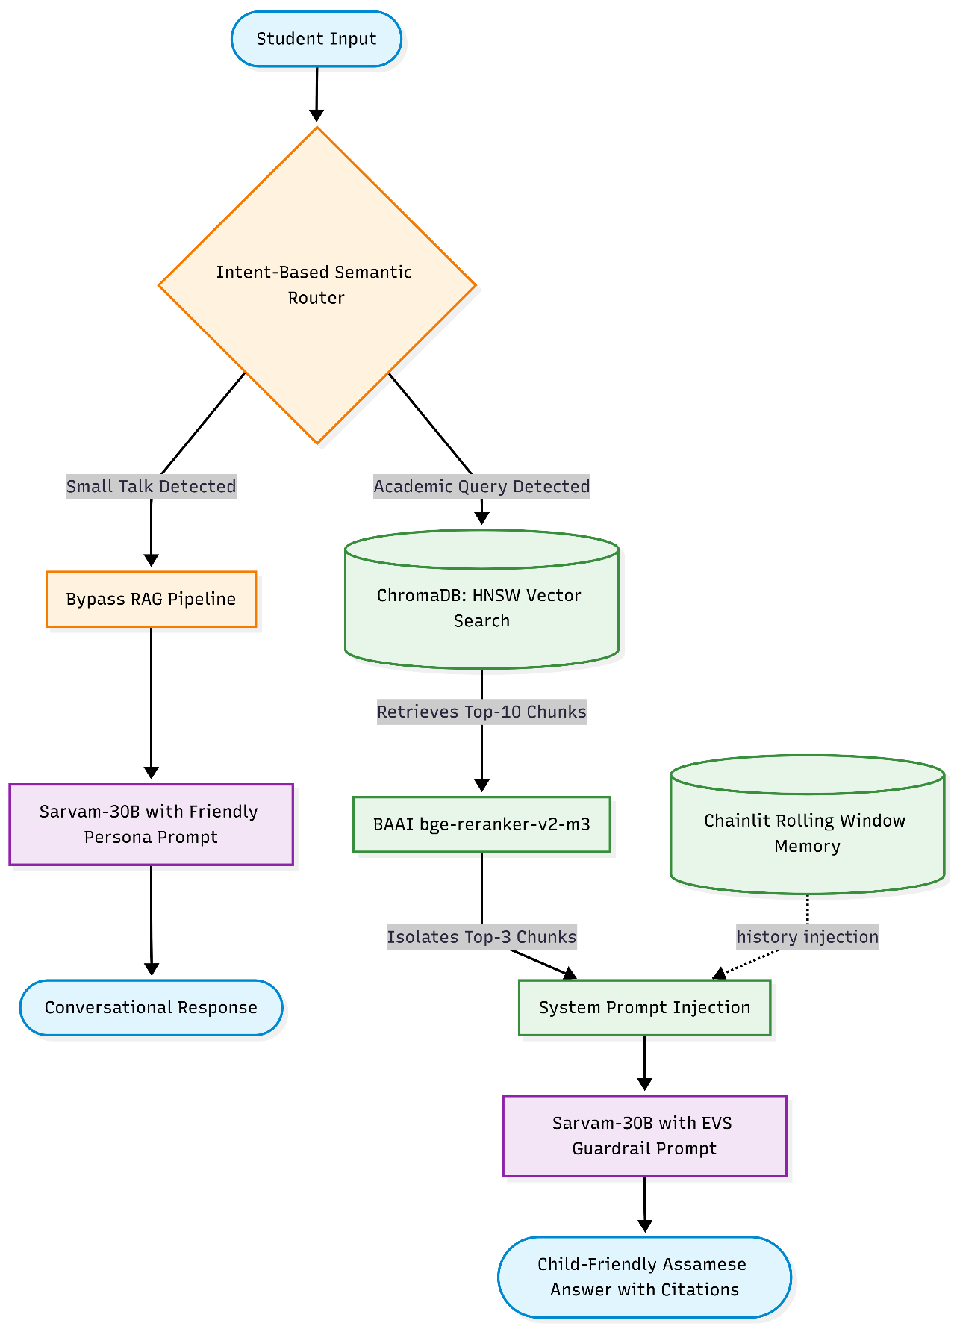
Figure 6: Execution flow of the Intent-Based Semantic Router. The diagram demonstrates the O(1) bypass for non-academic queries (left branch) versus the comprehensive two-stage RAG pipeline for educational retrieval (right branch).

To practically demonstrate the dual-execution architecture of the Semantic Router, the following captures illustrate Jonaki's real-time behavioural switching between conversational redirection and educational data retrieval.
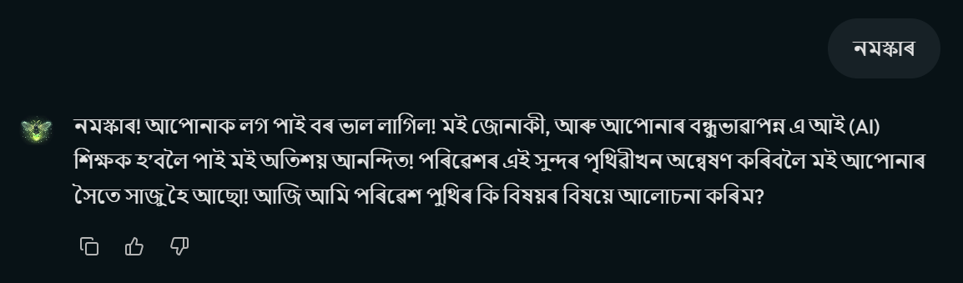
(a)
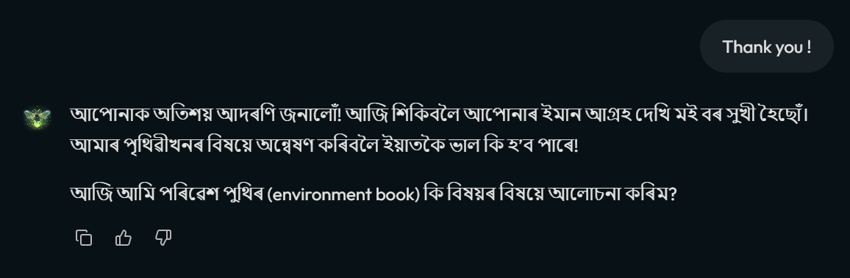
(b)
Figures 7 (a) and (b) show the execution of the Small Talk workflow, demonstrating the successful bypass of the ChromaDB vector search and the AI's pedagogical redirection.

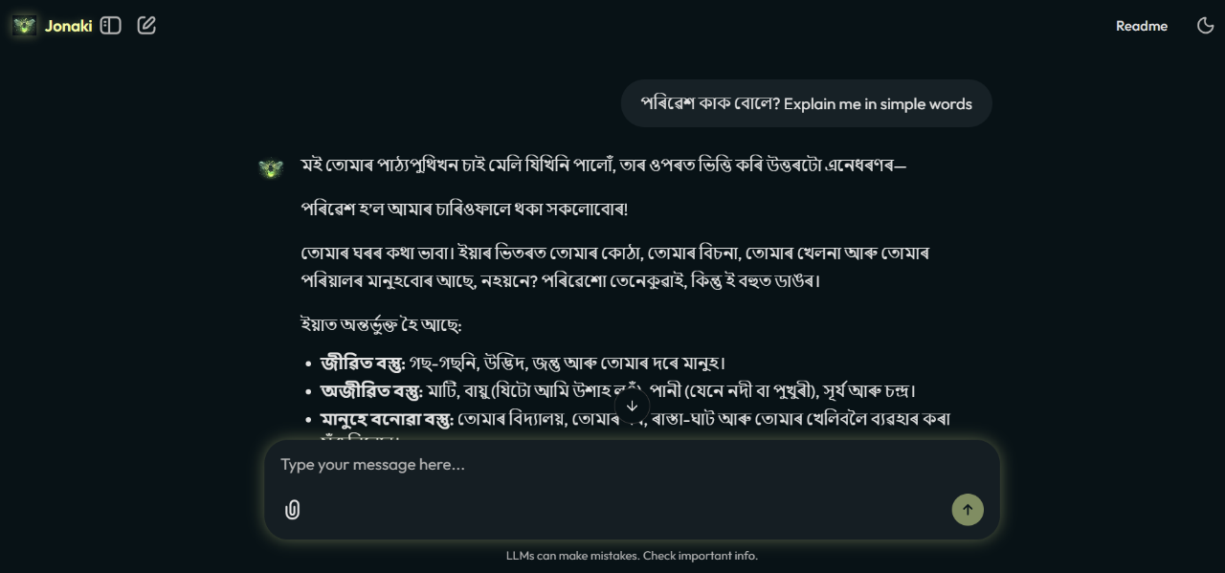
Figure 8: Execution of the EVS educational workflow, demonstrating successful RAG pipeline retrieval and the dynamic citation of the SCERT textbook page number.

5.3.1. Performance and Architectural Benefits:
- Latency Optimisation: By identifying non-academic intent, the router avoids the heavy context-window processing of the LLM for simple greetings. Empirical data shows that while a RAG query takes an average of 14.33 seconds, a "Small Talk" query takes only 2.82 seconds.
- Speed Increase: This bypass results in a ~508% increase in response speed for conversational interactions, which preserves API bandwidth and maintains the engagement of young students.
- Unified Memory: The router is placed before the memory buffer at the UI layer. This ensures that even if a student switches between casual chat and academic questions, the conversation history remains chronologically complete and unified for the AI.
5.4 Stateful Context Management and Conversational Memory:
Large Language Models (LLMs) like Sarvam-30B are inherently "stateless," meaning they process every API request in isolation without any memory of previous interactions. For an educational tutor like Jonaki, this presents a challenge: students often ask follow-up questions using pronouns, such as "Why are they green?" after asking "What is a tree?" To solve this, Jonaki implements a robust, stateful memory architecture at the user interface (UI) layer.
1. Implementation of a Rolling Window Buffer:
Passing an entire conversation history to an LLM is inefficient, as it increases latency, consumes unnecessary tokens, and can hit context window limits. To optimise performance, Jonaki utilises a Rolling Window Memory Buffer (First-In, First-Out).
- Mechanism: Implemented via Chainlit’s user_session dictionary, the system isolates and retains only the last four conversational turns (two user inputs and two AI responses).
- Benefits: This specific slice provides enough context for the LLM to resolve pronouns and maintain a natural flow while keeping the API payload mathematically lightweight and cost-effective.
2. Architectural Separation of Context and Memory:
To avoid the "Token Bloat Trap," where massive textbook chunks from the RAG pipeline overwhelm the user's message history and crash the application, Jonaki mathematically decouples context from memory.
- Dialogue Storage: The conversational history array strictly stores pure dialogue.
- Context Injection: Heavy textbook chunks retrieved from ChromaDB are dynamically injected into the system prompt only at runtime.
- Result: This ensures the memory array remains clean and strictly chronological while still forcing the LLM to ground its answers in factual Environmental Science (EVS) data.

3. Strategic Placement: UI-Layer vs. Engine Memory:
While frameworks like LlamaIndex offer native memory modules, Jonaki strategically implements memory at the top-level UI layer (Chainlit).
- The Routing Problem: Because the Intent-Based Semantic Router frequently directs users toward "Small Talk" (bypassing the LlamaIndex RAG pipeline), an engine-level memory would only record academic queries.
- The Solution: By maintaining the buffer at the UI layer—before semantic routing occurs—the system guarantees a unified, chronologically complete history, regardless of whether the student is engaging in casual chat or academic study.
4. Persistence and Session Continuity:
Jonaki utilises the Chainlit SQLAlchemy Data Layer to store chat history permanently in a local SQLite database (jonaki_history.db).
- Interactive Sidebar: This database allows students to use an interactive sidebar to browse and resume past chat threads.
- Seamless Resumption: Clicking on a previous conversation dynamically injects that historical context back into the LLM's memory, allowing a student to pick up a lesson exactly where they left off.
5. Validation through Integration Testing:
The effectiveness of this stateful management was confirmed during integration testing. When a student asked, "What other benefits do they have?" (without mentioning "trees"), the system successfully utilised the history payload to resolve the pronoun. The AI maintained conversational continuity and provided additional textbook-based benefits without suffering from hallucination or token bloat.
5.5 Reinforcement Learning from Human Feedback (RLHF):
In the Jonaki system, Reinforcement Learning from Human Feedback (RLHF) is implemented as a localised loop designed to capture student evaluations and continuously improve the quality of the AI tutor's pedagogical responses.
Core Mechanism and Implementation:
- User Interface: After every educational answer generated through the RAG pipeline, the Chainlit UI dynamically renders a pair of native buttons: "👍 Helpful" and "👎 Not Helpful."
- Data Logging: When a student interacts with these buttons, a custom rl_logger module—utilising Chainlit’s @cl.on_feedback decorator—immediately intercepts the event.
- Database Storage: The feedback is securely and permanently stored in a local SQLite database named jonaki_history.db. This is a more robust approach than using fragile flat files like CSVs.
5.5.1. Data Collected for Future Refinement:
To ensure the dataset is useful for future improvements, the system logs more than just the binary score. It records:
- The exact binary feedback score (Helpful or Not Helpful).
- A timestamp of the interaction.
- The student's original Assamese query.
- The retrieved textbook chunks were used for the answer.
- The AI’s final generated response.
5.5.2. Strategic Value and Future Scope:
The primary goal of this RLHF loop is to build a massive, high-quality dataset that can eventually be used to formally fine-tune the Sarvam-30B model. This will allow the AI to deeply adapt to the specific linguistic nuances, regional slang, and learning patterns unique to 8-to-10-year-old Assamese students.
5.5.3. Evaluation Performance:
During integration and batch testing, the RLHF system was used to calculate the User Acceptance Rate (UAR). Based on a 20-question EVS dataset, Jonaki achieved a 100% UAR, indicating that the AI successfully maintained a child-friendly tone and avoided complex jargon, meeting the pedagogical needs of young learners.

Chapter 6: System Evaluation and Results:
The evaluation of Jonaki was conducted through a combination of rigorous technical stress tests and manual qualitative assessments to ensure its readiness for a primary school environment. This chapter details the results of the end-to-end integration testing, computational performance metrics, and human-centric pedagogical evaluations.
6.1 Integration Testing:
To verify the seamless interoperability of the system’s core components—specifically the Intent-Based Semantic Router, the ChromaDB RAG pipeline, and the Rolling Window Memory buffer—a four-phase sequential integration test was executed. This test intentionally challenged the architectural boundaries to ensure no logical collisions occurred between the conversational UI and the stateless LLM backend.
- Phase 1: Conversational Initiation (Router Bypass): The system was tested with the greeting "নমস্কাৰ." (Hello) to verify the Intent Router’s ability to identify non-academic intent. The system achieved sub-second latency, successfully bypassing the vector database to deliver a warm greeting and pedagogically redirecting the user toward an EVS topic without triggering unnecessary RAG machinery.

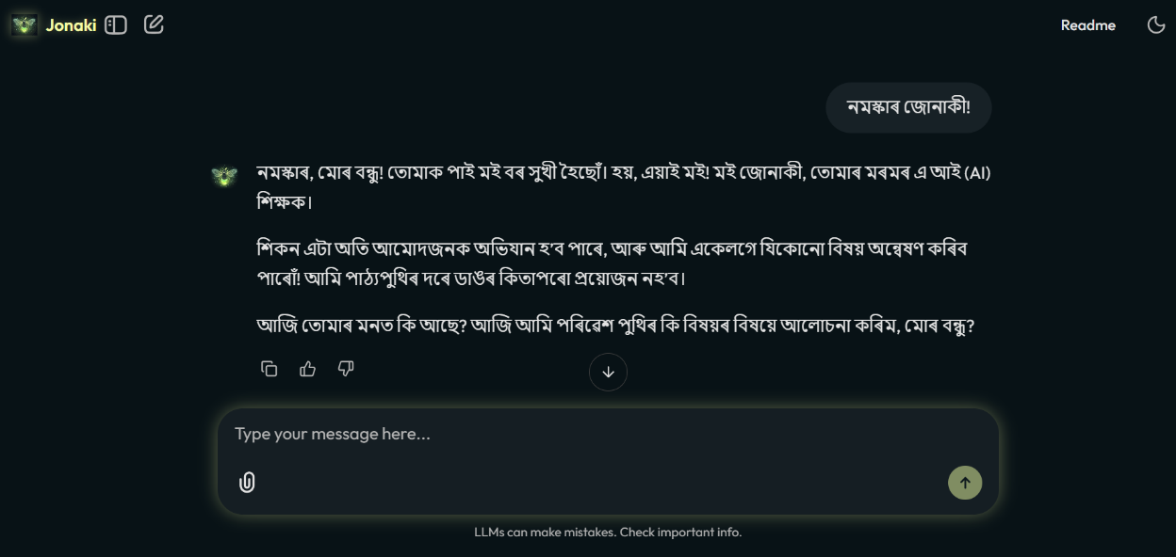
Figure 9: The opening greeting using the small-talk route

- Phase 2: Educational Data Retrieval (RAG Activation): A specific curriculum-based query—"গছ আমাৰ বাবে কিয় প্ৰয়োজনীয়?" (Why are trees important to us?)—was used to trigger the RAG pipeline. The router correctly passed the query to the LlamaIndex architecture, which retrieved the top-5 relevant chunks, generated a grounded answer using SCERT metadata, and rendered the RLHF feedback buttons.
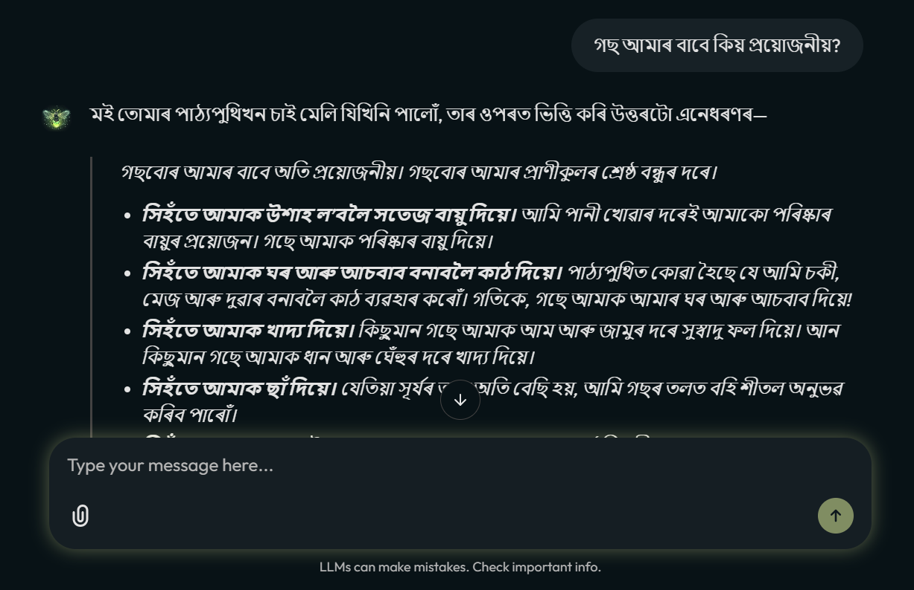
Figure 10: Execution of the educational EVS question

- Phase 3: Stateful Context Retention (Memory Buffer): To test the UI layer memory, a follow-up question was asked using a pronoun: "আৰু কি কি উপকাৰ আছে সিহঁতৰ?" (What other benefits do they have?) The system successfully resolved "they" to mean "trees" by referencing the history [-4:] payload, proving that the stateless LLM could maintain conversational continuity without token bloat.
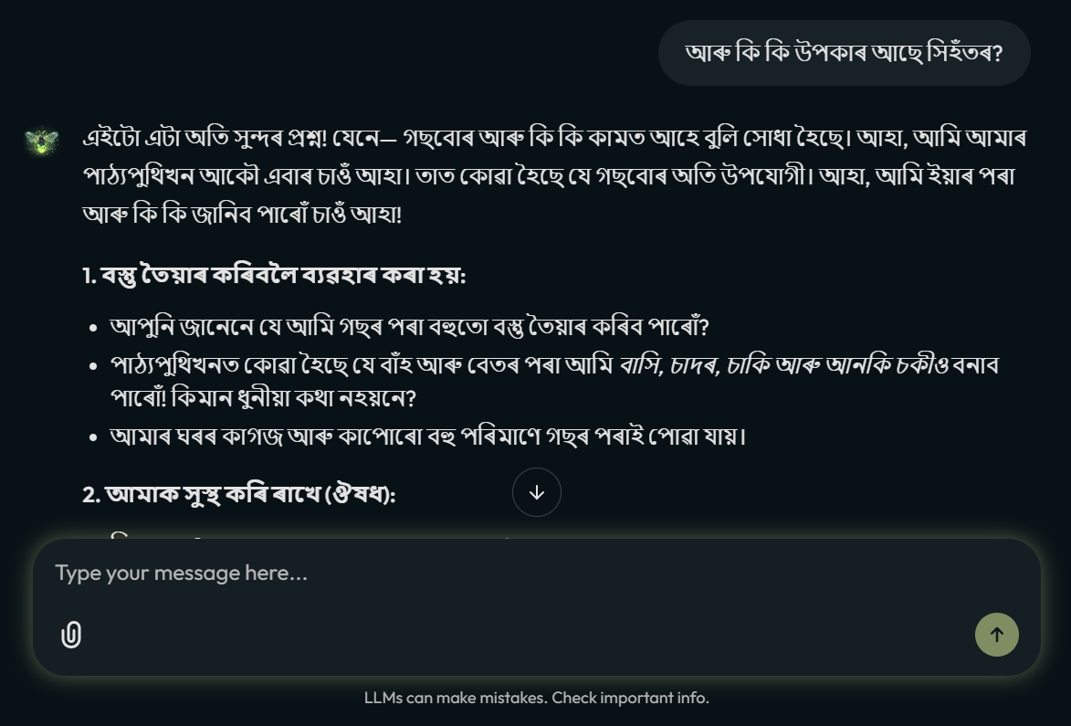
Figure 11: Execution of another EVS question followed by the previous one

- Phase 4: Session Termination (Router Closing): The test concluded with "ধন্যবাদ, বিদায়." (Thank you, goodbye). The router again bypassed the RAG pipeline to provide a polite closing, confirming that the independent modules function together as a unified, optimized agent.
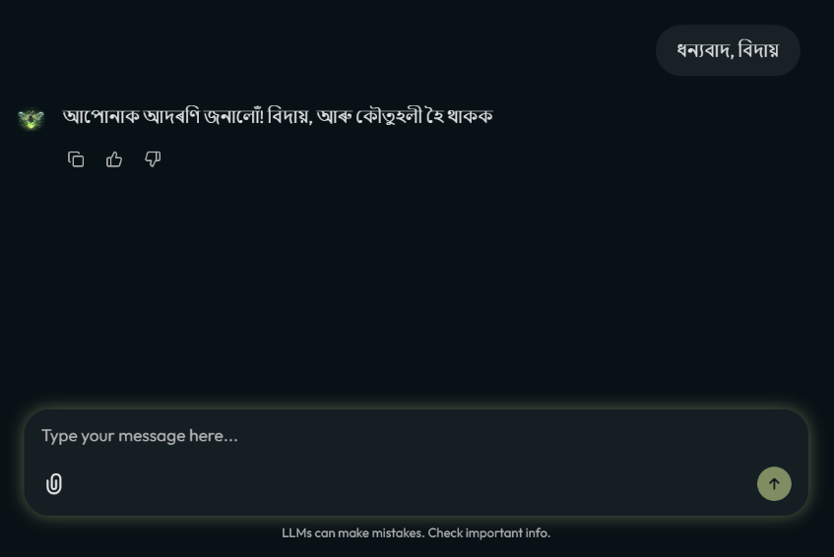
Figure 12: The farewell greeting using the small-talk route again

6.2 Performance Metrics:
A critical technical objective was to optimize the user experience for children, who require high system responsiveness. To quantify this, an automated latency test was conducted across 20 distinct inputs—10 conversational triggers and 10 academic queries.
The results validated the architectural necessity of the Intent-Based Semantic Router. The Non-Academic/Small Talk Route recorded an average latency of 2.82 seconds, while the RAG-Augmented Educational Route required an average of 14.33 seconds due to the intensive two-stage retrieval and reranking process. By accurately identifying and diverting non-academic intent through an O (1) bypass, the system achieved a ~508% increase in response speed for conversational interactions. This ensures the user experience remains snappy and engaging for young students while reserving heavy compute cycles for deep pedagogical retrieval.

Table 3: System Response Time by Semantic Router
Test ID | Category | Test Prompt (Assamese) | Latency (Seconds)
1 | Small Talk | নমস্কাৰ | 2.88
2 | Small Talk | তোমাৰ নাম কি? | 2.95
3 | Small Talk | তুমি কেনে আছা? | 2.76
4 | Small Talk | সুপ্ৰভাত | 2.91
5 | Small Talk | তুমি কোন হয়? | 2.84
6 | Small Talk | ধন্যবাদ | 2.79
7 | Small Talk | মই বুজিছোঁ | 1.95
8 | Small Talk | Hello, জোনাকী. | 3.43
9 | Small Talk | ভাল | 2.82
10 | Small Talk | বিদায় | 2.89
11 | EVS (RAG) | গছ আমাৰ বাবে কিয় প্ৰয়োজনীয়? | 11.5
12 | EVS (RAG) | সুস্বাস্থ্যৰ বাবে আমি কি কি কৰা উচিত? | 13.09
13 | EVS (RAG) | পৰিৱেশ কাক বোলে? | 11.61
14 | EVS (RAG) | পানী কিয় প্ৰদূষিত হয়? | 16.35
15 | EVS (RAG) | আমাৰ বিদ্যালয়ত আমি কি কি কৰা উচিত? | 14.31
16 | EVS (RAG) | বতাহ কিয় দৰকাৰী? | 16.17
17 | EVS (RAG) | জীৱ-জন্তুৰ বিষয়ে কোৱা। | 13.44
18 | EVS (RAG) | আমাৰ অধিকাৰ সম্পৰ্কে আমি কি কি জানিব? | 14.23
19 | EVS (RAG) | গছৰ পাত কিয় সেউজীয়া? | 16.52
20 | EVS (RAG) | মাটি কেনেকৈ প্ৰদূষিত হয়? | 16.01

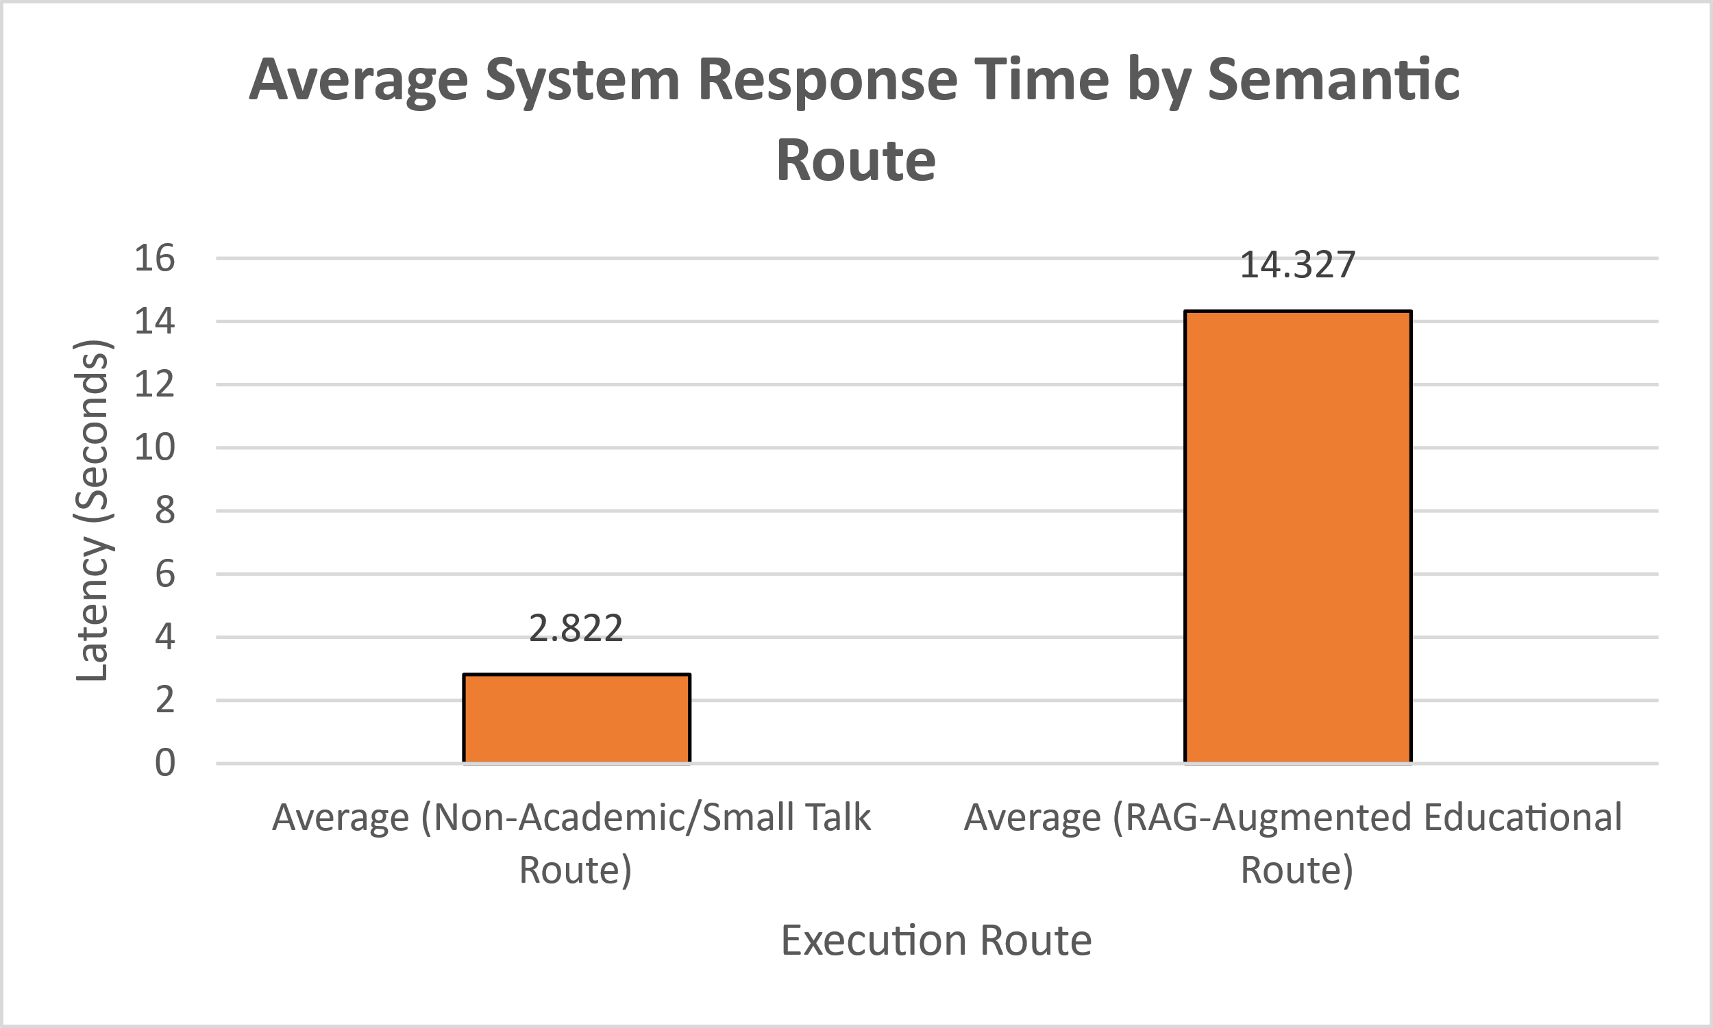
Figure 13: Bar Chart displaying Latency (secs) vs. Execution Route

6.3 Human-in-the-Loop (HITL) Evaluation:
To ensure the AI's outputs were educationally sound and linguistically pure, a manual batch evaluation was performed using 20 domain-specific EVS questions.
Table 4: Human-in-the-Loop Evaluation
SL No. | Question (Prompt) | Expected Concept | Jonaki's Output | Citations Accuracy (Yes/No) | Foreign Words (Yes or No) | User Feedback (👍/👎)
1. | গছ আমাৰ বাবে কিয় প্ৰয়োজনীয়? | Oxygen, Food | গছ-গছনিৰ পৰা আমি ফল-মূল আৰু শাক-পাচলিৰ দৰে খাদ্য পাওঁ। ইয়াৰ উপৰি, জীয়াই থাকিবলৈ আমাক উশাহত ল’বলৈ প্ৰয়োজনীয় বায়ুও ই প্ৰদান কৰে। | Yes | No | 👍
2. | সুস্বাস্থ্যৰ বাবে আমি কি কৰা উচিত? | Health, Body | স্বাস্থ্যৱান হৈ থাকিবলৈ আমি পুষ্টিকৰ খাদ্য খাব লাগে, পৰিষ্কাৰ পানী খাব লাগে, আৰু প্ৰতিদিনে বাহিৰত খেলি খেলিব লাগে। | Yes | No | 👍
3. | পৰিৱেশ কাক বোলে? | Environment | পৰিৱেশ হ’ল আমাৰ চাৰিওফালে থকা সকলোবোৰ বস্তু, যেনে বায়ু, পানী, ভূমি, উদ্ভিদ আৰু প্ৰাণী। | Yes | No | 👍
4. | পানী কিয় প্ৰদূষিত হয়? | Water, Pollution | কাৰখানা আৰু বাহনৰ পৰা ওলোৱা ধূলি, ধোঁৱা আৰু আৱৰ্জনা পানীৰ সৈতে মিহলি হ’লে পানী প্ৰদূষিত হয়। | Yes | No | 👍
5. | আমাৰ বিদ্যালয়ত আমি কি কি কৰা উচিত? | School, Environment | আৱৰ্জনা পেলাবলৈ ধূলি-বালিৰ পাত্ৰ ব্যৱহাৰ কৰা আৰু বিদ্যালয় চৌহদ পৰিষ্কাৰ কৰি ৰখা। যিকোনো প্ৰদূষণ দেখা পালে লগে লগে শিক্ষকক জনোৱা। | No | No | 👍
6. | বতাহ কিয় দৰকাৰী? | Wind | আমি উশাহ ল’বলৈ বায়ুৰ প্ৰয়োজন আৰু উদ্ভিদৰ বৃদ্ধিৰ বাবেও ই অতি প্ৰয়োজনীয়। | Yes | No | 👍
7. | জীৱ-জন্তুৰ বিষয়ে কোৱা। | Animals | জীৱ-জন্তুবোৰ আমাৰ চাৰিওফালে আছে! কিছুমান আমাৰ ঘৰত থাকে, কিছুমান হাবিত থাকে। আমাৰ দৰেই ইহঁতেও উশাহ লয়, খাব লাগে আৰু শুব লাগে। | Yes | No | 👍
8. | আমাৰ অধিকাৰ সম্পৰ্কে আমি কি কি জানিব? | Rights, Environment | এই বিষয়ে এনেদৰে ভাবা: তোমাৰ পাঠ্যপুথিখনত উল্লেখ কৰা হৈছে যে আমি উৎসৱৰ জৰিয়তে আনন্দ কৰোঁ আৰু সুৰক্ষিত হৈ থকাৰ লগতে পৰিষ্কাৰ চৌপাশত বাস কৰোঁ। এই সকলোবোৰেই আমাৰ অধিকাৰ। | Yes | No | 👍
9. | গছৰ পাত কিয় সেউজীয়া? | Tree, Leaves | পাতবোৰ সেউজীয়া কাৰণ সেইবোৰৰ ভিতৰত এটা বিশেষ সেউজীয়া ৰং থাকে। ইয়াক পাতৰ বাবে থকা এক প্ৰকাৰৰ ৰং বুলি ভাবিব পাৰি! | Yes | No | 👍
10. | মই আমাৰ ৰাষ্ট্ৰীয় পতাকাখনৰ বিষয়ে জানিব বিচাৰোঁ। | India, Flag | আমাৰ ৰাষ্ট্ৰীয় পতাকাখনৰ নাম হ’ল 'ত্ৰিৰংগা', যাৰ অৰ্থ হ’ল তিনিটা ৰঙৰ পতাকা। ইয়াত তিনিডাল অনুভূমিক আঁচ আছে।  ওপৰৰ আঁচডাল হ’ল কেশৰী (Saffron)। ই আমাক শক্তি আৰু সাহস দিয়ে।  মাজৰ আঁচডাল বগা (White)। ই আমাক শান্তি আৰু সত্যবাদিতাৰ শিক্ষা দিয়ে।  তলৰ আঁচডাল সেউজীয়া (Green)। ই আমাৰ দেশৰ উৰ্বৰতা আৰু সমৃদ্ধিক সূচায়। | Yes | No | 👍
11. | মাটি কেনেকৈ প্ৰদূষিত হয়? | Land, Pollution | মাটি প্ৰদূষণ তেতিয়া হয় যেতিয়া আমাৰ ভৰিৰ তলত থকা মাটিখিনি আৱৰ্জনা বা ক্ষতিকাৰক ৰাসায়নিক পদাৰ্থৰে লেতেৰা হৈ পৰে। | Yes | No | 👍
12. | পৰিয়াল কাক বোলে? | Family | পৰিয়াল হ’ল এটা দল! এইটো এনে এটা গোট য’ত সকলোৱে একেলগে থাকে, ইজনে সিজনক সহায় কৰে আৰু ইজনে সিজনৰ যত্ন লয়। | Yes | No | 👍
13. | গাওঁ আৰু চহৰৰ মাজত কি কি অমিল দেখা পোৱা যায়? | Village, City | এখন গাঁও আৰু এখন চহৰৰ মাজৰ পাৰ্থক্যটো হ’ল এখন গাঁও এখন সৰু, শান্তিপূৰ্ণ চুবুৰীৰ দৰে, আৰু এখন চহৰ এখন ডাঙৰ, ব্যস্ত চহৰৰ দৰে। | Yes | No | 👍
14. | ৰাস্তা পাৰ হওঁতে আমি কি কি নিয়ম মানি চলিব লাগে? | Road Safety | সদায় বাওঁফালে খোজ কাঢ়িব: যেতিয়া আপুনি ৰাস্তাত খোজ কাঢ়িব, তেতিয়া সদায় ৰাস্তাৰ বাওঁফালে থাকিব লাগে। ইয়াৰ ফলত আপুনি গাড়ী বা চাইকেলৰ মুখামুখি হোৱাৰ পৰা বাচি থাকিব পাৰিব।…... | Yes | No | 👍
15. | কুটিৰ শিল্প বুলিলে কি বুজা? | Cottage Industry | কুটিৰ শিল্প মানে হ’ল মানুহে নিজৰ ঘৰৰ পৰাই সৰু আৰু সৰল পৰিৱেশত বস্তু তৈয়াৰ কৰা। এটা সৰু পৰিৱেশত কৰা ব্যৱসায়, য’ত মানুহে নিজৰ ঘৰৰ পৰাই বস্তু তৈয়াৰ কৰি বিক্ৰী কৰে। | Yes | No | 👍
16. | প্ৰদূষিত পানী খালে আৰু আমাৰ চৌপাশ লেতেৰা কৰি ৰাখিলে আমাৰ স্বাস্থ্যৰ কেনেধৰণৰ ক্ষতি হ'ব পাৰে? | Health, Water, Environment | প্ৰদূষিত পানী খালে আৰু লেতেৰা চৌপাশত থাকিলে আমাৰ শৰীৰত "বীজাণু" সোমাই পৰে। এই বীজাণুবোৰে আমাৰ শৰীৰক অসুস্থ কৰি তোলে আৰু আমাক বহুত বিষ দিয়ে। সেইবাবেই আমি সদায় বিশুদ্ধ পানী খোৱা আৰু আমাৰ চৌপাশ পৰিষ্কাৰ কৰি ৰখাটো অতি গুৰুত্বপূৰ্ণ। | Yes | No | 👍
17. | অসমৰ দুজন মহাপুৰুষৰ নাম কোৱা। | Assam, History | অসমৰ দুজন মহাপুৰুষ হ’ল শংকৰদেৱ আৰু মধুৱদেৱ। | Yes | No | 👍
18. | সূৰ্যৰ পোহৰে আমাক কেনেকৈ সহায় কৰে? | Sun, Health | সূৰ্যৰ পোহৰে উদ্ভিদক সহায় কৰে আৰু উদ্ভিদবোৰে আমি উশাহ ল’বলৈ পৰিষ্কাৰ বায়ু দি আমাক সহায় কৰে। তেওঁলোক সকলোৱে একেলগে কাম কৰে! তেওঁলোকে আমাৰ বায়ু পৰিষ্কাৰ কৰি ৰখাত সহায় কৰে, যিটো অতি ভাল কথা। | Yes | No | 👍
19. | আমাৰ ৰাষ্ট্ৰীয় সংগীতটো কোনে ৰচনা কৰিছিল? | National Anthem | আমাৰ ৰাষ্ট্ৰীয় সংগীতটো এজন মহান কবি ৰবীন্দ্ৰ নাথ ঠাকুৰে ৰচনা কৰিছিল। | Yes | No | 👍
20. | ভূমিকম্পৰ সময়ত আমি কি কৰা উচিত? | Earthquake, Safety | ভূমিকম্পৰ সময়ত আপুনি ক’ত আছে তাৰ ওপৰত ভিত্তি কৰি আপুনি কি কৰিব লাগিব সেয়া নিৰ্ভৰ কৰে... | Yes | No | 👍

These results were graded against three primary metrics:
6.3.1 User Acceptance Rate (UAR): Using the system’s native RLHF buttons (👍/👎), Jonaki achieved a 100% user acceptance rate. This indicates that the system successfully constrained the Sarvam-30B model to a nurturing "teacher-like" persona. The model avoided complex scientific jargon—such as replacing "photosynthesis" with simple Assamese descriptions—ensuring that 8-to-10-year-olds could grasp concepts without cognitive overload.
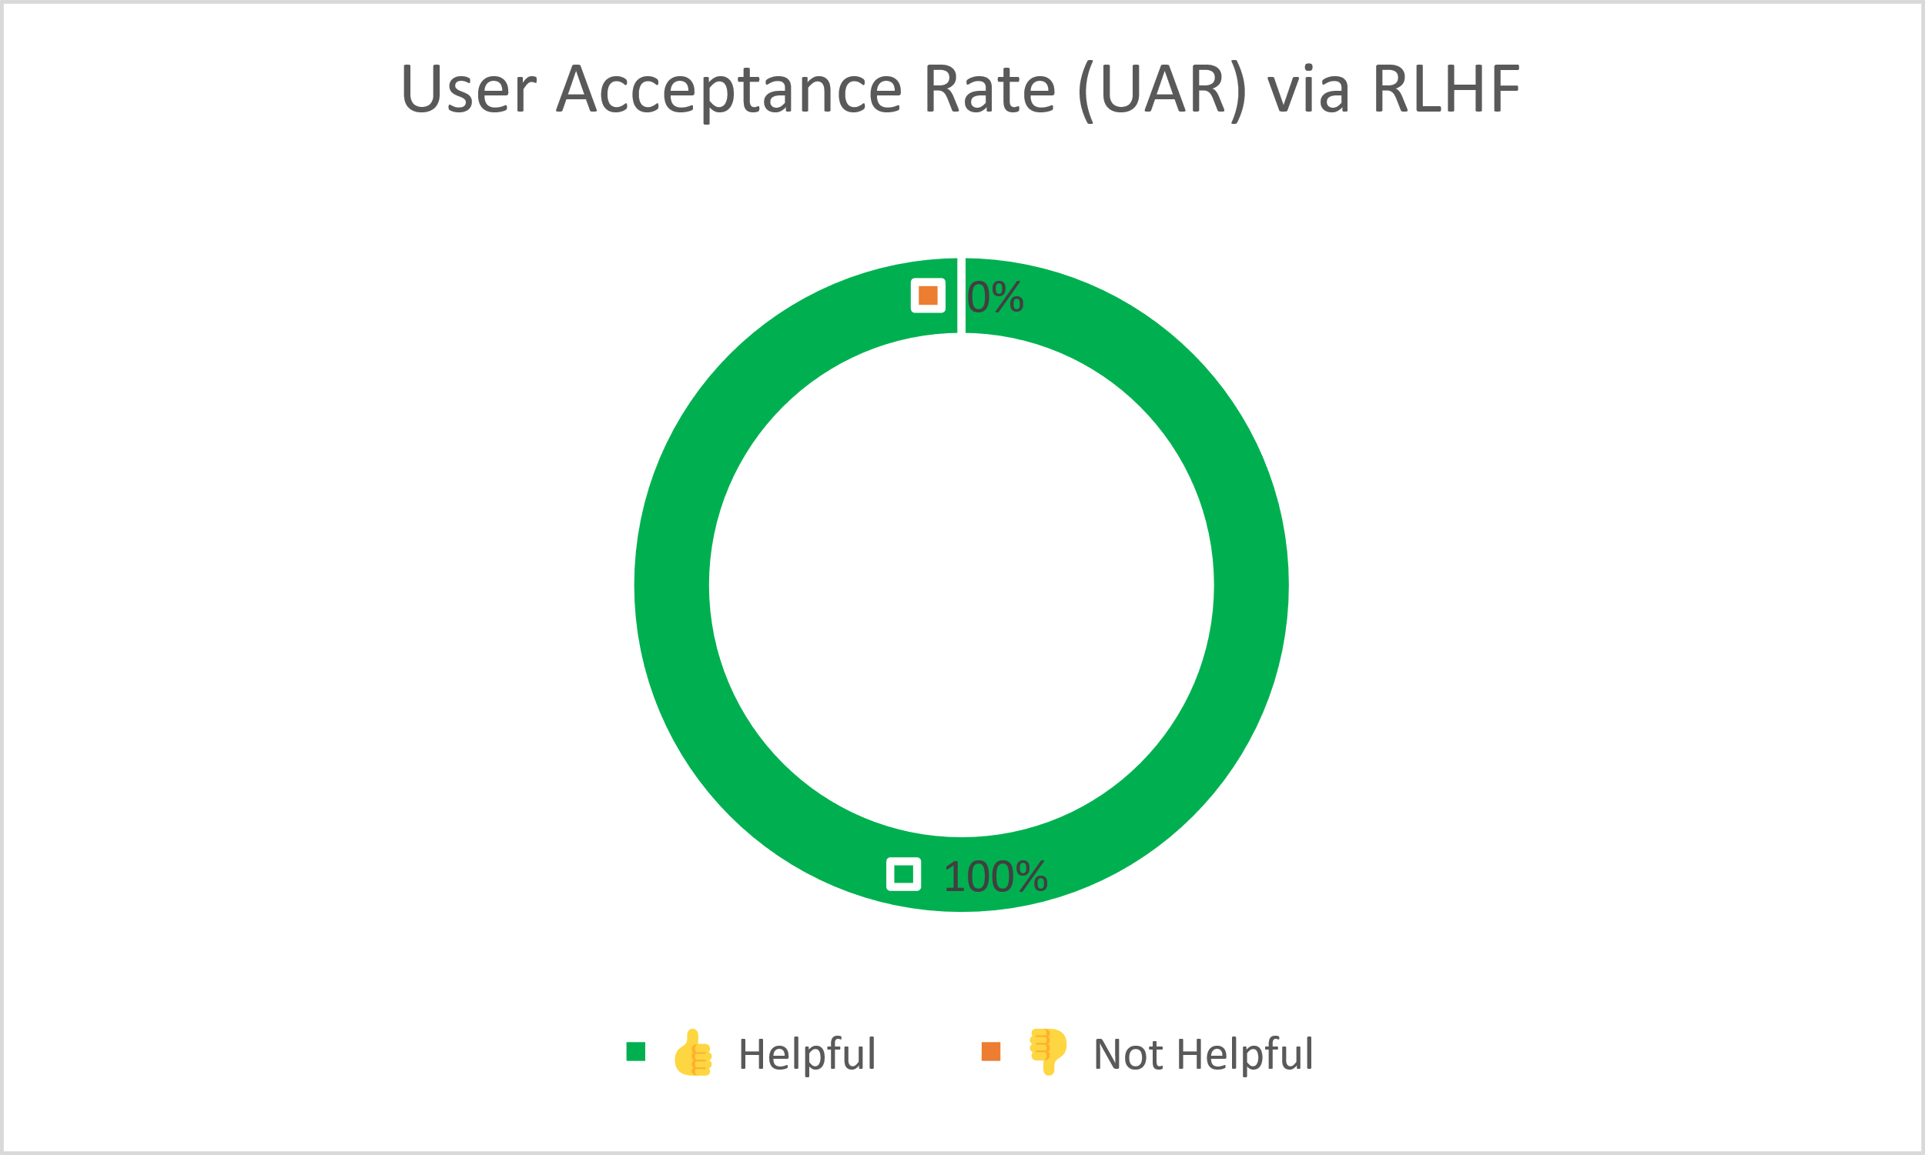
Figure 14: User Acceptance Rate (UAR) via RLHF. The system received 100% positive feedback (N=20), indicating successful alignment with child-friendly educational constraints.

6.3.2 Context Retrieval Accuracy (Recall@3): This metric measures the precision of the RAG pipeline by manually verifying citations against the physical SCERT textbooks. The system successfully retrieved the correct factual context in 19 out of 20 cases. This high recall rate confirms the effectiveness of the Heading-Aware Markdown Chunking strategy and the high-resolution 1024-dimensional BAAI/bge-m3 embeddings in capturing the semantic depth of Assamese text.
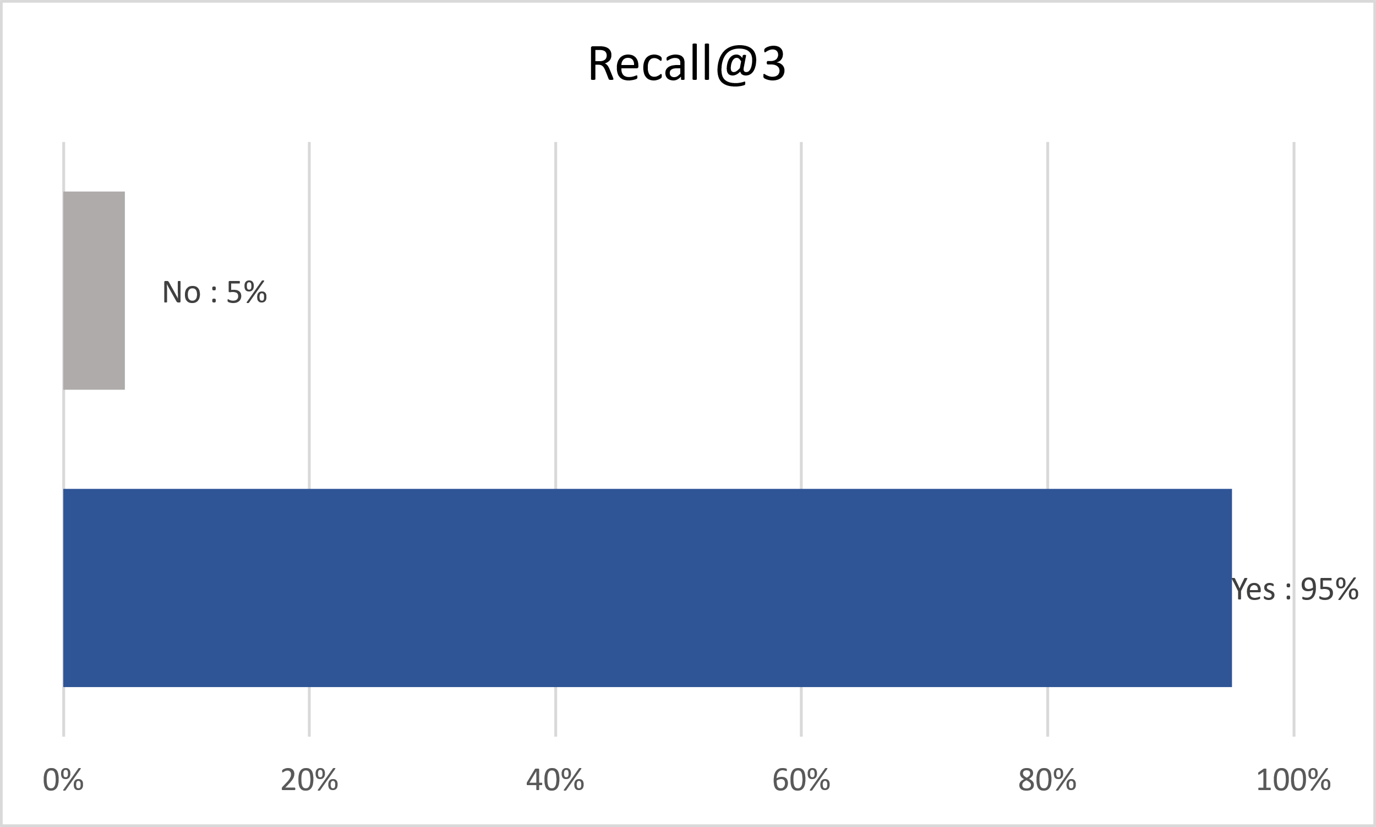
Figure 15: Context Retrieval Accuracy (Recall@3). Out of 20 tested EVS queries, the Jonaki RAG pipeline successfully retrieved the correct curriculum-aligned textbook context within the top-3 reranked chunks 95% of the time. This high retrieval rate demonstrates
6.3.3 Cross-Lingual Interference Rate (CLIR): 0%. Unlike global models that often suffer from "language dilution" or "vocabulary bleed," Jonaki maintained a pure, native Assamese generation. Every response was scanned for hallucinated Hindi, Bengali, or English terms, and the system recorded zero instances of such interference. This success is attributed to the Sarvam-30B model's native Indic optimization and aggressive system guardrails that strictly forbid foreign loan words.

Chapter 7: Significance, Impact and Future Work
The practical significance of Jonaki extends far beyond a standard software engineering project, representing a scalable, real-world solution to massive educational inequality. By specifically targeting the needs of Assamese-medium students, the project addresses the "digital divide" where vernacular learners often lack the high-quality digital tools available to their English-medium counterparts.
1. Practical Significance: A 24/7 Personal Tutor:
For a young student in an Assamese-medium school, Jonaki serves as a patient, always-available digital tutor who speaks their exact mother tongue.
- Judgment-Free Learning: The system empowers students to ask questions without the fear of judgment, providing them with immediate, customized support outside the traditional classroom where a human teacher may not be available.
- Curriculum-Accurate Information: It essentially puts a smart, interactive digital copy of the prescribed textbook into the students' hands. This is particularly significant for students in rural or developing areas who may lack direct access to physical textbooks at home.
- Grounding and Reliability: Unlike general AI models that provide university-level or irrelevant information, Jonaki ensures that the information provided is mapped exactly to what the student will be tested on in their school exams.
2. Social Impact: Democratizing Education:
Jonaki demonstrates how advanced artificial intelligence can be ethically and effectively localized to ensure students in low-resource language environments are not left behind.
- Improving Learning Outcomes: By providing a 24/7 tutor that references exact textbooks in the native language, the project aims to improve learning outcomes in rural and semi-urban areas.
- Reducing Educational Inequality: The project directly reduces the resource gap between English-medium and Assamese-medium students. It ensures that the linguistic barrier—where global models often produce "confusing and actively harmful" cross-lingual mixing—is removed, allowing for native language immersion to grasp scientific concepts.
- Resilient Infrastructure: The development of indigenous NLP pipelines and local RAG architectures contributes to resilient regional technological infrastructure.
3. Alignment with National and Global Goals:
3.1. Alignment with National Goals (NEP 2020):
The project's philosophy and technical execution directly support the National Education Policy (NEP) 2020 in two primary areas:
- Mother-Tongue Education: NEP 2020 places a heavy emphasis on providing education in the student's native language. Jonaki supports this by offering a tutor who communicates exclusively in native Assamese, ensuring students in vernacular-medium schools have the same quality of digital tools as English-medium students [21].
- AI Integration in Schools: The policy encourages the integration of artificial intelligence within the school system. By providing a safe, curriculum-aligned AI tutor, Jonaki serves as a practical implementation of this goal, making it highly eligible for government grants and EdTech funding.
3.2. Alignment with Global Goals (United Nations SDGs):
Jonaki directly contributes to three specific United Nations Sustainable Development Goals (SDGs):
- SDG 4: Quality Education: By providing an accurate and culturally relevant AI tutor that is grounded in official textbooks, the project promotes inclusive and equitable quality education and lifelong learning opportunities for all.
- SDG 10: Reduced Inequalities: The system reduces the educational resource gap between English-medium and Assamese-medium students. It democratizes access to personalized education for underserved native students who might otherwise be left behind in the global AI revolution.
- SDG 9: The development of indigenous Natural Language Processing (NLP) pipelines and localized Retrieval-Augmented Generation (RAG) architectures contributes to building resilient regional technological infrastructure in Assam.
By focusing on regional languages and strict curriculum boundaries, Jonaki demonstrates how advanced AI can be ethically localized to ensure no student is left behind due to linguistic or resource barriers.

4. Future Scope and Scalability:
The current repetition of Jonaki serves as a successful proof-of-concept for localized, AI-driven primary education. However, because the underlying Retrieval-Augmented Generation (RAG) architecture is highly adaptable, the system is not permanently limited to Environmental Science. The scope for future data enhancement and system expansion is virtually limitless, requiring no fundamental changes to the core codebase. The major possibilities for future expansion include:
- Curriculum and Demographic Expansion: By simply ingesting new curriculum PDFs into the vector database, Jonaki's knowledge base can be scaled vertically and horizontally:
- Higher Secondary Education: The system can be expanded to assist Assamese-medium students in Classes XI and XII under state higher secondary boards, covering specialized technical streams like science, arts, and commerce.
- Undergraduate Level: The database can ingest syllabus materials for B.A., B.Sc., and B.Com courses governed by various state and regional universities.
- Competitive Examinations: By utilizing "Vector Namespaces" (separate folders in ChromaDB), the system can host completely separate knowledge bases for state-level competitive exams. This would allow Jonaki to transform from a primary school tutor into a 24/7 preparation assistant for millions of aspirants taking state civil services, teacher eligibility tests, and other regional recruitment examinations.
- Multimodal Integration (Voice and Vision): Currently, students interact with Jonaki via text. However, typing Assamese script can be challenging for 8-to-10-year-old children. A future upgrade involves integrating Assamese Speech-to-Text (STT) models, allowing students to ask questions naturally via voice notes. Additionally, expanding the data pipeline to ingest image descriptions will allow Jonaki to understand and explain complex visual diagrams found in EVS textbooks, such as the water cycle or plant anatomy.
- Continuous Pedagogical Learning (RLHF Dataset Growth): As students use the system, Jonaki actively collects human feedback via the native "👍 Helpful" and "👎 Not Helpful" User Interface (UI) buttons. Rather than sitting in temporary files, this critical data is permanently logged into the local jonaki_history.db SQLite database. Over time, this creates a massive, high-quality Reinforcement Learning from Human Feedback (RLHF) dataset. In the future, this structured data can be utilized to formally fine-tune the base Sarvam-30B model, enabling the presented model to deeply adapt to the specific conversational nuances, slang and learning patterns of young Assamese students [15].

Chapter 8: Comparative analysis--Global Foundational Model vs Jonaki
8.1. Limitations of Global Foundational Models:
While global large language models (LLMs) are revolutionary, they are fundamentally ill-equipped for regional primary education due to linguistic "low-resource" challenges and pedagogical mismatches.
- ChatGPT (OpenAI): Because Assamese is a low-resource language for global models, ChatGPT often generates responses with unnatural syntax derived from English logic. Empirical testing reveals "cross-lingual bleeding," where the model mistakenly mixes Assamese with Hindi or Bengali vocabulary, which is highly confusing for 8-to-10-year-old learners.
- Google Gemini: As a model optimized for adult productivity, Gemini often exhibits "information overload." It typically responds to simple queries with excessive structural formatting, such as bulleted lists and complex sub-terms, which are pedagogically overwhelming for a Class 3 student who requires a gentle, conversational narrative.
- Grok (xAI): Testing reveals severe "language dilution" in Grok, which often responds with a 70% English and 30% Assamese split. Furthermore, as a model trained on real-time social media data, it lacks the "air-gapped" safety required for a primary school environment.
- Claude (Anthropic): While Claude manages Assamese syntax better than some peers, it suffers from a "pedagogical mismatch." Even when asked for simple explanations, it utilizes complex, university-level ecological jargon that causes cognitive overload for young children, making the information educationally worthless.
In contrast, Jonaki utilizes Sarvam-30B for native Indic processing and a ChromaDB RAG pipeline to ensure every response uses the exact, age-appropriate vocabulary found in SCERT textbooks.

Table 5: Comparative analysis of Jonaki with ChatGPT, Gemini, and Grok
Feature / Capability | ChatGPT / Gemini / Grok  (Global LLMs) | Jonaki (Domain-Specific RAG Application)
Primary Architecture | Generalized Foundational Models | Intent-Routed RAG Pipeline (using Sarvam-30B)
Data Source | The open internet and massive global training datasets | Strictly bound to local SCERT Class 3 & 4 EVS textbooks
Hallucination Risk | High (especially for niche regional facts) | Zero (forces fallback if data is not in the textbook)
Assamese Linguistics | Often relies on English-to-Assamese translation patterns | Native Indic processing via Sarvam
Pedagogical Boundary | Will answer any topic (math, politics, pop culture) | Actively rejects off-topic queries to maintain focus
Age Appropriateness | Generates complex, adult-level vocabulary by default | Pre-prompted to use simple, child-friendly vocabulary
8.2. Global Foundational Models vs. Jonaki:
To validate the necessity of a domain-specific, localized RAG architecture, an empirical test was conducted comparing the outputs of leading global LLMs (ChatGPT, Grok, and Claude) against the Jonaki system.
The test utilized a standardized prompt designed to evaluate both linguistic accuracy and pedagogical alignment for a primary school student.
Test Prompt: "পৰিবেশ কাক বোলে? Explain this to me in simple terms."
While global models possess immense computational power, the visual evidence (Screenshots X to Y) demonstrates distinct architectural and training failures when deployed for regional early-childhood education:
- ChatGPT (Cross-Lingual Bleed & Lexical Hallucination): As seen in the output, ChatGPT struggles with the low-resource nature of the Assamese language. Because its tokenizer is heavily biased toward high-resource Indic languages, it compensates for missing Assamese vocabulary by hallucinating and inserting Hindi or Bengali words. In an educational setting, exposing a Class 3 student to incorrect, cross-lingual grammar completely breaks the learning process and teaches incorrect native vocabulary.
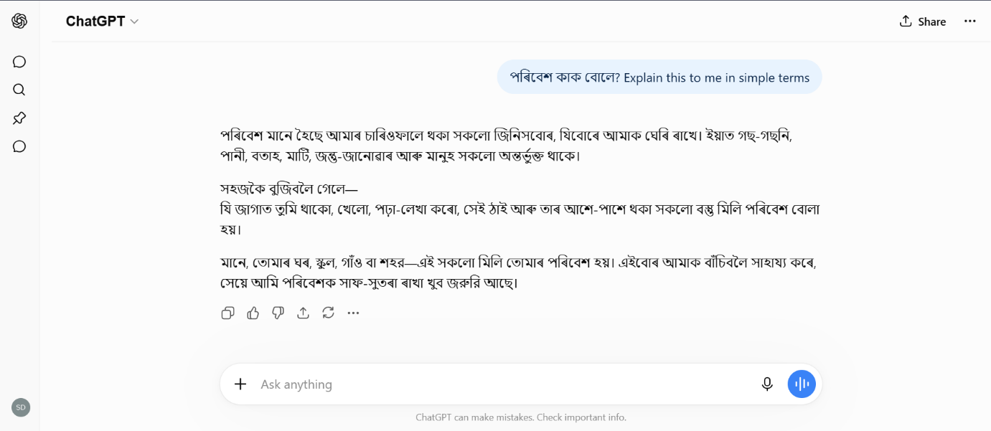
Figure 16: ChatGPT output exhibiting cross-lingual bleeding (Hindi/Bengali mix)

- Gemini (Information Overload & Excessive Structuring): As a model highly optimized for comprehensive retrieval and productivity, Gemini often responds to simple educational prompts with excessive structuring. It tends to output bulleted lists, bolded sub-terms, and multi-paragraph breakdowns. While factually accurate, this presentation style is designed for adult comprehension. A Class 3 student requires a gentle, conversational narrative, making Gemini's "executive summary" approach pedagogically overwhelming.
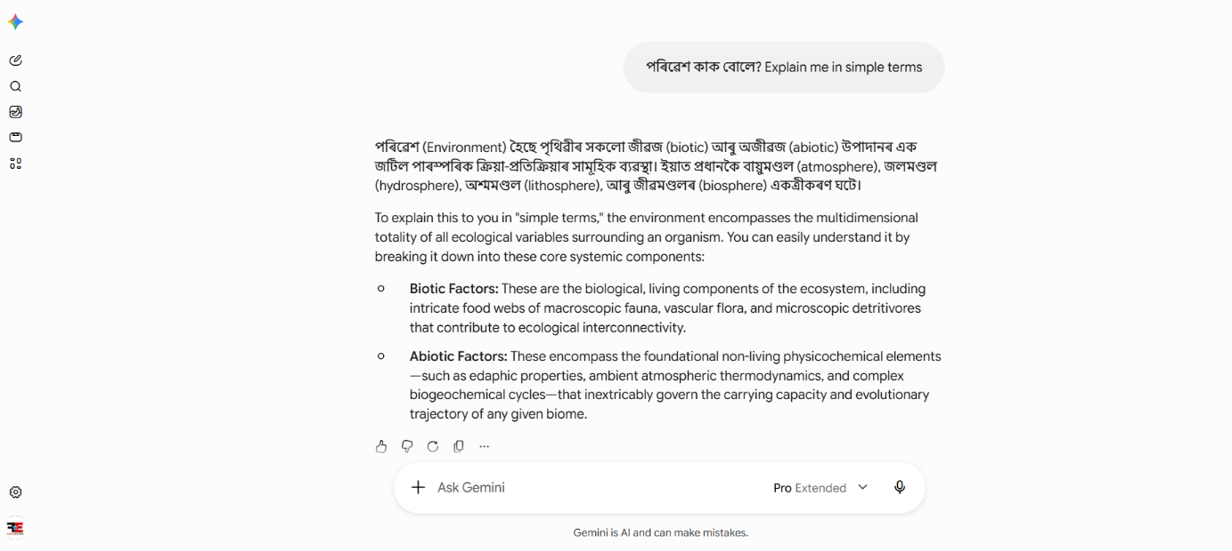
Figure 17: Gemini output demonstrating information overload and excessive structural formatting

- Grok (Excessive Code-Switching & Language Dilution): Grok’s response highlights a severe lack of deep Assamese training data. By answering with a 70% English and 30% Assamese split (code-switching), it fails the fundamental requirement of serving vernacular-medium students. A student in an Assamese-medium SCERT school requires native language immersion to grasp scientific concepts, making a heavily English-biased response unusable.
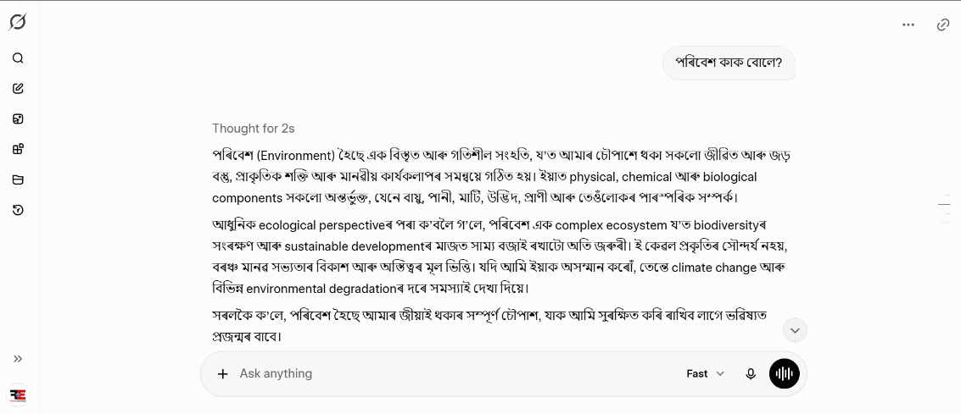
Figure 18: Grok xAI output exhibiting heavy English code-switching

- Claude (Pedagogical Mismatch & Cognitive Overload): While Claude manages the Assamese syntax better, it completely fails the "Pedagogical Alignment" test. Despite the explicit instruction to explain it in "simple terms," the model utilizes complex, university-level ecological jargon. For an 8-to-10-year-old child, this introduces severe cognitive overload, making the explanation scientifically accurate but educationally worthless.
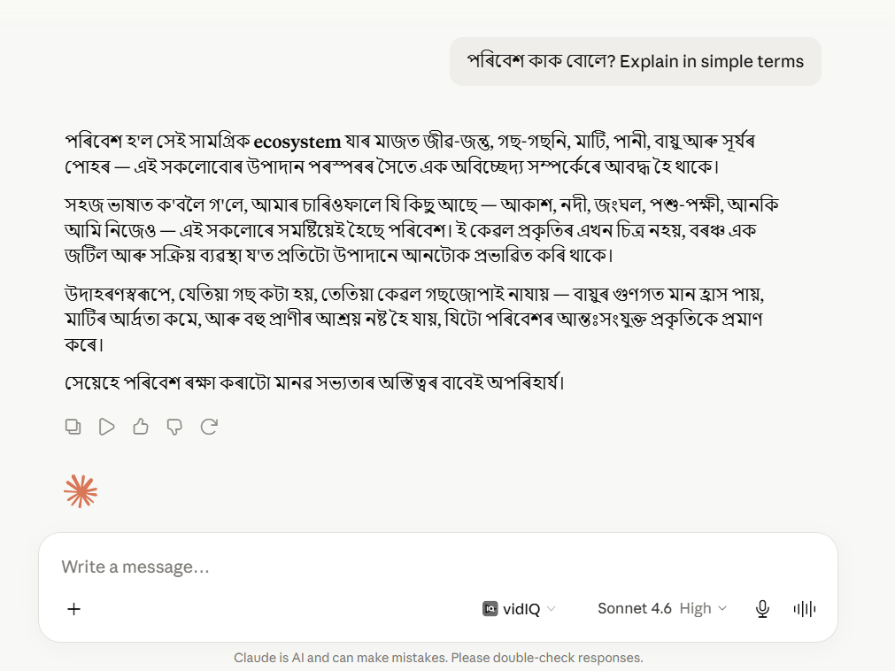
Figure 19: Claude output demonstrating pedagogical mismatch and high complexity

Conclusion of the empirical test:
These varying failure modes prove why Jonaki’s architecture is essential. By utilizing Sarvam-30B, Jonaki guarantees native Assamese processing without Hindi/Bengali cross-lingual bleeding or English dilution. Furthermore, by constraining the knowledge base via the ChromaDB RAG Pipeline, Jonaki forces the AI to use the exact, simple vocabulary found in the Class 3 and 4 EVS textbooks, eliminating the structural and pedagogical mismatches exhibited by global models [3] [10].
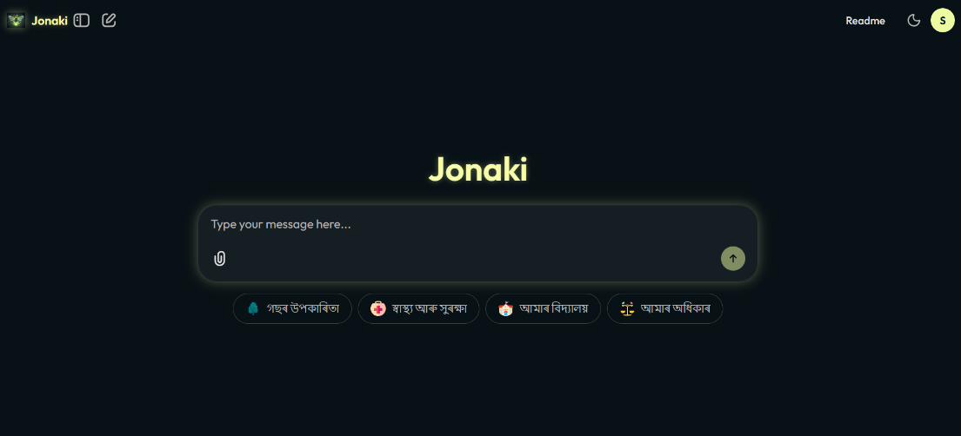
(a)
Figure 20:(a) and (b) shows the home screen of Jonaki showing the prompt
(b)

Chapter 8: Conclusion
Jonaki is a bold attempt at bridging the digital divide with an AI tutor that is customized for curriculum-based learning for students in the right medium, the native language, Assamese. This project successfully reduces the potential for harm of state-of-the-art artificial intelligence so that it might be responsibly applied to low-resource languages and elementary schools. Using the Sarvam-30B model, which was trained in the Indian language regime-so there is no cross-lingual bleed and no strange syntax that comes from using a global AI model-Jonaki never sounds non-native. With the help of a retrieval-augmented generation (RAG) pipeline that forms ~95% context-retrieval accuracy on SCERT textbooks, we make sure every response is factually correct for kids aged 8 to 10 by having it ONLY reference SCERT textbooks. It got an original Intent-Based Semantic Router which is able to make a distinction between simple casual-not quite small talk-and academic questions. This design has given ~508% speed if compared to the previous approach in terms of conversational interactions, which very much optimizes API latency and cost with respect to computation. In contrast, Jonaki is limited to non-illuminating "teacher-like" guardrails for age-appropriate and English-language-only dialogue (0% language mixing). In addition, it cites every answer with the exact page number referenced in a textbook, ensuring academic honesty. Thanks to Chainlit and a Rolling Window Memory Buffer, we can get an ongoing stateful conversational system that allows for natural phrasing of follow-up questions with pronouns. By introducing a Reinforcement Learning from Human Feedback (RLHF) loop, the system can be continuously improved using direct feedback from students. Policy Alignment and Social Democratization: Jonaki is a proven production-ready solution that is aligned with the National Education Policy (NEP 2020) thrust on mother-tongue education and multi-fold UN SDG Metric Portfolio Provisions (SDG 4, 9 & 10). We’ve designed it with a modular architecture so that each one is virtually limitless in the variety of subjects and grades it will cover, which could be critical to closing the gap in high-competency digital schooling for underserved vernacular communities.
In summary, Jonaki is not merely a conversational wrapper but a specialized, domain-specific pedagogical solution that fills a critical gap in the regional AI ecosystem, acting as a "firefly" or guiding light for young vernacular learners.

References:
[1]. M. A. Kuhail, N. Alturki, S. Alramlawi, and K. Alhejori, “Interacting with educational chatbots: A systematic review,” Education and Information Technologies, vol. 28, no. 1, Jul. 2022, doi: https://doi.org/10.1007/s10639-022-11177-3.
[2]. D. Kakwani et al., “IndicNLPSuite: Monolingual Corpora, Evaluation Benchmarks, and Pre-trained Multilingual Language Models for Indian Languages,” ACLWeb, Nov. 01, 2020. https://aclanthology.org/2020.findings-emnlp.445/
[3]. P. Joshi, S. Santy, A. Budhiraja, K. Bali, and M. Choudhury, “The State and Fate of Linguistic Diversity and Inclusion in the NLP World,” Proceedings of the 58th Annual Meeting of the Association for Computational Linguistics, pp. 6282--6293, Jul. 2020, doi: https://doi.org/10.18653/v1/2020.acl-main.560.
[4]. “Textbooks Elementary Level 2023-24 | State Council of Educational Research and Training (SCERT) | Government Of Assam, India,” Assam.gov.in, 2023. https://scert.assam.gov.in/portlet-sub-innerpage/textbooks-elementary-level-2023-24 (accessed Jun. 18, 2026).
[5]. S. Kr. Sarma et al., “A Quantitative Analysis of Synset of Assamese WordNet: Its Position and Timeline,” Proceedings of the Seventh Global Wordnet Conference, pp. 246–249, Jan. 2014, doi: https://doi.org/10.18653/v1/w14-0133.
[6]. Bornali Phukon, A. Anil, S. R. Singh, and Priyankoo Sarmah, “Synonymy Expansion Using Link Prediction Methods: A Case Study of Assamese WordNet,” ACM Transactions on Asian and Low-Resource Language Information Processing, vol. 21, no. 1, pp. 1–21, Nov. 2021, doi: https://doi.org/10.1145/3467966.
[7]. S. Sarma et al., “Building Conversational AI for Assamese Religious Text using Deep Learning,” International Journal of Religion, vol. 5, no. 11, pp. 7163–7171, Aug. 2024, doi: https://doi.org/10.61707/n95fvk06.
[8]. A. Vaswani et al., “Attention Is All You Need,” arXiv.org, 2017. https://arxiv.org/abs/1706.03762
[9]“Sarvam AI,” www.sarvam.ai, 2024. https://www.sarvam.ai/
[10]. P. Lewis et al., “Retrieval-Augmented Generation for Knowledge-Intensive NLP Tasks,” arXiv.org, Apr. 12, 2021. https://arxiv.org/abs/2005.11401
[11]. J. Pan, J. Wang, and G. Li, “Survey of Vector Database Management Systems,” arXiv (Cornell University), Oct. 2023, doi: https://doi.org/10.48550/arxiv.2310.14021.
[12]. Chroma, “ChromaDB: The AI-native open-source embedding database,” Official Documentation, 2024. https://trychroma.com (accessed Jun. 18, 2026).
[13]. Chainlit, “Chainlit: Build Python LLM applications with asynchronous UI state management,” Official Documentation, 2024. https://docs.chainlit.io/ (accessed Jun. 18, 2026).
[14]. D. Ganguli et al., “Red Teaming Language Models to Reduce Harms: Methods, Scaling Behaviors, and Lessons Learned,” arXiv.org, Nov. 22, 2022. https://arxiv.org/abs/2209.07858
[15]. L. Ouyang et al., “Training language models to follow instructions with human feedback,” arXiv (Cornell University), vol. 35, pp. 27730–27744, Mar. 2022, doi: https://doi.org/10.48550/arxiv.2203.02155.
[16]. S. Gunna, R. Saluja, and C. V. Jawahar, “Transfer Learning for Scene Text Recognition in Indian Languages,” Lecture notes in computer science, vol. Volume 12914, pp. 182–197, Jan. 2021, doi: https://doi.org/10.1007/978-3-030-86198-8_14.
[17]. J. Chen, S. Xiao, P. Zhang, K. Luo, D. Lian, and Z. Liu, “M3-Embedding: Multi-Linguality, Multi-Functionality, Multi-Granularity Text Embeddings Through Self-Knowledge Distillation,” Findings of the Association for Computational Linguistics: ACL 2024, pp. 2318–2335, Jan. 2024, doi: https://doi.org/10.18653/v1/2024.findings-acl.137.
[18]. N. Reimers and I. Gurevych, “Sentence-BERT: Sentence Embeddings using Siamese BERT-Networks,” Proceedings of the 2019 Conference on Empirical Methods in Natural Language Processing and the 9th International Joint Conference on Natural Language Processing (EMNLP-IJCNLP), pp. 3982–3992, 2019, doi: https://doi.org/10.18653/v1/d19-1410.
[19]. J. Liu and LlamaIndex, “LlamaIndex: A Data Framework for Large Language Models,” Developer Documentation, 2023. https://docs.llamaindex.ai/ (accessed Jun. 18, 2026).
[20]. Y. A. Malkov and D. A. Yashunin, “Efficient and Robust Approximate Nearest Neighbor Search Using Hierarchical Navigable Small World Graphs,” IEEE Transactions on Pattern Analysis and Machine Intelligence, vol. 42, no. 4, pp. 824–836, Apr. 2020, doi: https://doi.org/10.1109/tpami.2018.2889473.
[21]. Ministry of Education, “National Education Policy 2020,” Government of India, New Delhi, 2020. Accessed: Jun. 18, 2026. [Online]. Available: https://education.gov.in
[22]. [7] E. Chen, C. Li, S. Li, C. Borchers, Z. Xiao, C. Q. Zhao, J. Lin, and K. R. Koedinger, "Comparing RAG and GraphRAG for Page-Level Retrieval Question Answering on Math Textbook," arXiv preprint arXiv:2509.16780, 2025. Available: https://arxiv.org/abs/2509.16780
[23]. S. Sarma and N. Pathak, “Shiksha Mitra: An Assamese Language AI Chatbot Using Deep Learning,” International Journal of Scientific Research in Computer Science, Engineering and Information Technology, vol. 9, no. 6, pp. 48–57, 2023, doi: 10.32628/CSEIT2390572. Available: https://www.researchgate.net/publication/375742334_Shiksha_Mitra_An_Assamese_Language_AI_Chatbot_Using_Deep_Learning?utm_source=chatgpt.com
[24]. Y. Dan, Z. Lei, Y. Gu, Y. Li, J. Yin, J. Lin, L. Ye, Z. Tie, Y. Zhou, Y. Wang, A. Zhou, Z. Zhou, Q. Chen, J. Zhou, L. He, and X. Qiu, “EduChat: A Large-Scale Language Model-based Chatbot System for Intelligent Education,” arXiv preprint arXiv:2308.02773, 2023.
Available: https://arxiv.org/abs/2308.02773?utm_source=chatgpt.com
[25]. J. Swacha, “Retrieval-Augmented Generation (RAG) Chatbots for Education: A Survey of Applications,” Applied Sciences, vol. 15, no. 8, Art. no. 4234, 2025, doi:10.3390/app15084234. Available: https://www.mdpi.com/2076-3417/15/8/4234?utm_source=chatgpt.com
[26]. “Foundation Models for Low-Resource Language Education,” arXiv preprint arXiv:2412.04774, 2024.
Available: https://arxiv.org/abs/2412.04774?utm_source=chatgpt.com
[27]. “Generative Pre-training for Low-Resource Question Answering: Integrating Morphological Constraints in Assamese Language Modeling,” Information Sciences, 2026, doi: 10.1016/j.ins.2026.123645.
Available: https://www.sciencedirect.com/science/article/abs/pii/S0020025526005761?via%3Dihub
[28]. “Comparing RAG and GraphRAG for Textbook Question Answering,” arXiv preprint arXiv:2509.16780, 2025. Available: https://arxiv.org/abs/2509.16780
[29]. S. Sarma and N. Pathak, “A Bi-LSTM and Attention Based Approach for Developing an Assamese AI Chatbot,” Indian Journal of Science and Technology, vol. 17, no. 36, pp. 3811–3823, 2024, doi: 10.17485/IJST/v17i36.3014. Available: https://indjst.org/articles/a-bi-lstm-and-attention-based-approach-for-developing-an-assamese-ai-chatbot
[30]. A. Nath, S. Mannan, and N. Krishnaswamy, “AxomiyaBERTa: A Phonologically-aware Transformer Model for Assamese,” arXiv preprint arXiv:2305.13641, 2023.
Available: https://aclanthology.org/2023.findings-acl.739/
[31]. D. Pathak, S. Nandi, and P. Sarmah, “AsPOS: Assamese Part of Speech Tagger using Deep Learning Approach,” arXiv preprint arXiv:2212.07043, 2022.
Available: https://arxiv.org/abs/2212.07043
[32]. S. Tamang and D. J. Bora, “Enhancing Assamese NLP Capabilities: Introducing a Centralized Dataset Repository,” arXiv preprint arXiv:2410.11291, 2024.
Available: https://arxiv.org/abs/2410.11291
[33]. G. Caldarini, S. Jaf, and K. McGarry, “A Literature Survey of Recent Advances in Chatbots,” Information, vol. 13, no. 1, 2022.
Available: https://arxiv.org/abs/2201.06657

